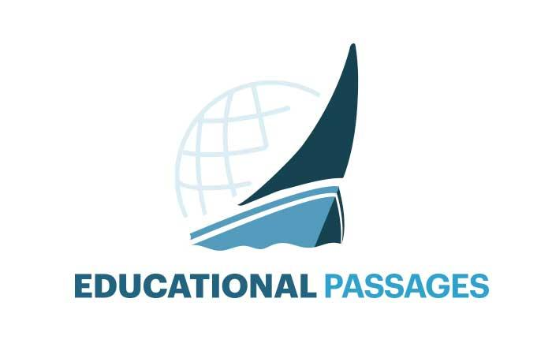 | Global Connection Questions

Overview
The following questions should be completed by a class, printed, and stowed in the boat’s document holder. Please email your answers to miniboats@educationalpassages.com so they can be stored electronically. These questions are geared toward culture, environmental conditions, and community understanding.

Boat name: _____________________________ | School/organization: ________________________________________________________
Country/state: ______________________________________________ |  | Today’s date (month/day/year): ______________________

Culture & the Classroom
- What is the primary language spoken in your school?

- What other languages are spoken in your school and community?

- What are the most common religions practiced in your community?

Environment & Geography
- Is your school in the country, in a town, or in a city?

- What are the main environmental problems that affect your community?

- What is the closest body of water to your school?

- Would you swim in that body of water? Why or why not?

Government, History & Economics
- What currency do you use and what is the exchange rate to the United States Dollar today?

- What form of governance does your country have?

- When was your country founded?

- What are the main sources of employment in your community?

- What are the primary industries in your country/state?

