Elementary Unit 1 | Ocean Mechanics
  - Unit Overview

Unit Goals
Big Idea: What are the mechanics behind ocean processes?
Abstract: In this Earth Science unit, Elementary-level students explore the oceanic and atmospheric mechanics behind ocean physics. The first lesson, Shoreline Erosion, engages the students, connecting them and their schoolyards to a phenomenon threatening coastal communities. They then explore mechanics causing erosion in the Waves lesson and explain wave formation in the climate-based Trade Winds lesson. In the final lesson, Surface Currents, students model the Thermocline and use data gathered by Educational Passages to evaluate the impact of ocean mechanics.
Ocean Literacy Principles:
- The Earth has one big ocean with many features.
- The ocean and life in the ocean shape the features of Earth.
- The ocean is a major influence on weather and climate.
NGSS Crosscutting Concepts: (1) Patterns; (4) Systems and system models; (5) Energy and matter
NGSS Practices: (1) Asking questions; (6) Constructing explanations; (7) Engaging in argument from evidence

Contents
Item  Unit Overview  Explanation and Glossary  Lesson 01 | Shoreline Erosion  Lesson 02 | Waves  Lesson 03 | Trade Winds  Lesson 04 | Currents  Student Pages | Pages  1  2 through 7  8 through 11  12 through 16  17 through 20  21 through 25  26 and 27

Elementary School Unit 1 | Ocean Mechanics
  - Explanation and Glossary

Ocean Mechanics Explanation
In this Earth Science unit, students explore the atmospheric and hydrologic phenomena responsible for ocean mechanics and the impact of these mechanics on other Earth processes.
Most students will be familiar with beaches and shorelines, but some may not know of their ever-changing nature. We begin the unit by engaging this change. Students will explore erosion in their schoolyards, observing the removal of sediment by rainfall. This exposes the cohesive and adhesive nature of water, essential properties which contribute to ocean mechanics. Cohesion occurs when water is attracted to water, whereas adhesion occurs when water is attracted to other substances. Cohesion can be seen in water droplets and wave structures, and adhesion plays a role in shoreline erosion. In both cases, positively charged hydrogen atoms and negatively charged oxygen atoms, seen in Figure 1.01, create molecular bonds responsible for this attraction.
Breaking waves greatly contribute to shoreline erosion. The amplitude, the vertical height of a wave, and wavelength, the distance from crest to crest, determine a wave’s power. As waves near the shoreline and water depth decreases, the amplitude increases and wavelength decreases until its height reaches a critical level, causing the wave to break. Figure 1.02 illustrates these mechanics. The moon and sun’s gravitational pull form tidal waves, but this unit focuses on wind waves. The following four factors determine wind wave formation: (1) wind speed, (2) wind duration, (3) affected surface area, and (4) depth of water.
To understand the mechanics behind wind formation, students must explore the uneven heating of Earth’s surface. Earth’s biomes, ecological areas with similar climates and geology, reveal this temperature inequality. Biomes range from warmer areas near the equator, such at the tropics and sub-tropical deserts, to colder areas near Earth’s poles, such as tundra and boreal forests. The temperature differences responsible for this biotic variation also contribute to atmospheric circulation. Air warmed near the equator rises to the poles where it cools, sinks, and moves back toward the equator, seen in Figure 1.03. This movement contributes to trade wind formation. These perpetual winds blow from the northeast in the northern hemisphere and the southeast in the southern hemisphere.
Water also warms at the equator. Warmer equatorial water continuously flows toward the cooler poles, forming the ocean’s major currents. As the water cools, it sinks. The dramatic decrease in temperature between ocean layers called the thermocline, depicted in Figure 1.04, contributes to the worldwide circulation of ocean water. This circulation, known as the global conveyor belt, brings warm water to the poles and cold, nutrient-rich water to warmer environments. The global conveyor belt, displayed in Figure 1.05, supports ocean ecosystems around the world.
To set the context for student-led action planning, this unit links ocean mechanics and society. Hurricane preparedness may directly apply to your community. Hurricanes occur when a tropical storm strengthens over warm water and builds to a critical speed. When hurricanes make landfall, they create a storm surge, temporary sea level rise due to atmospheric changes. Storm surge damages property and poses a danger to affected communities.

Appendix
Figure 1.01 | Water Molecule
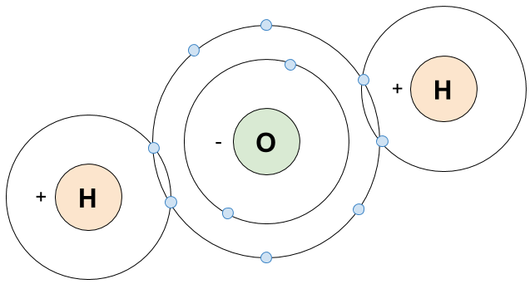

Figure 1.02 | Breaking Waves
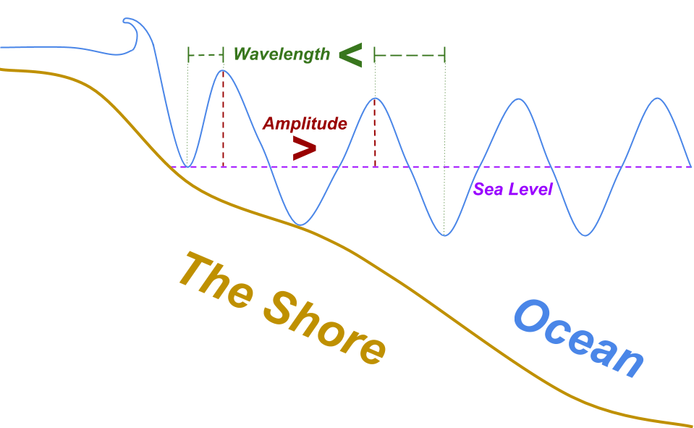
Figure 1.03 | Equator and the Poles

Figure 1.04 | Thermocline
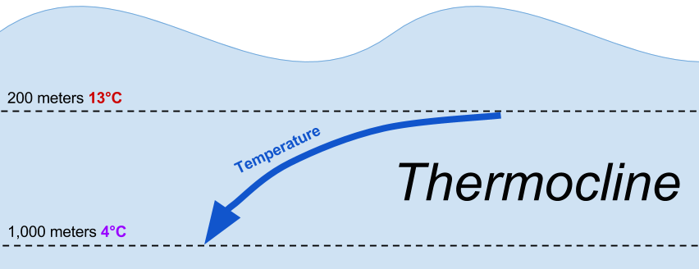
Figure 1.05 | The Global Conveyor Belt
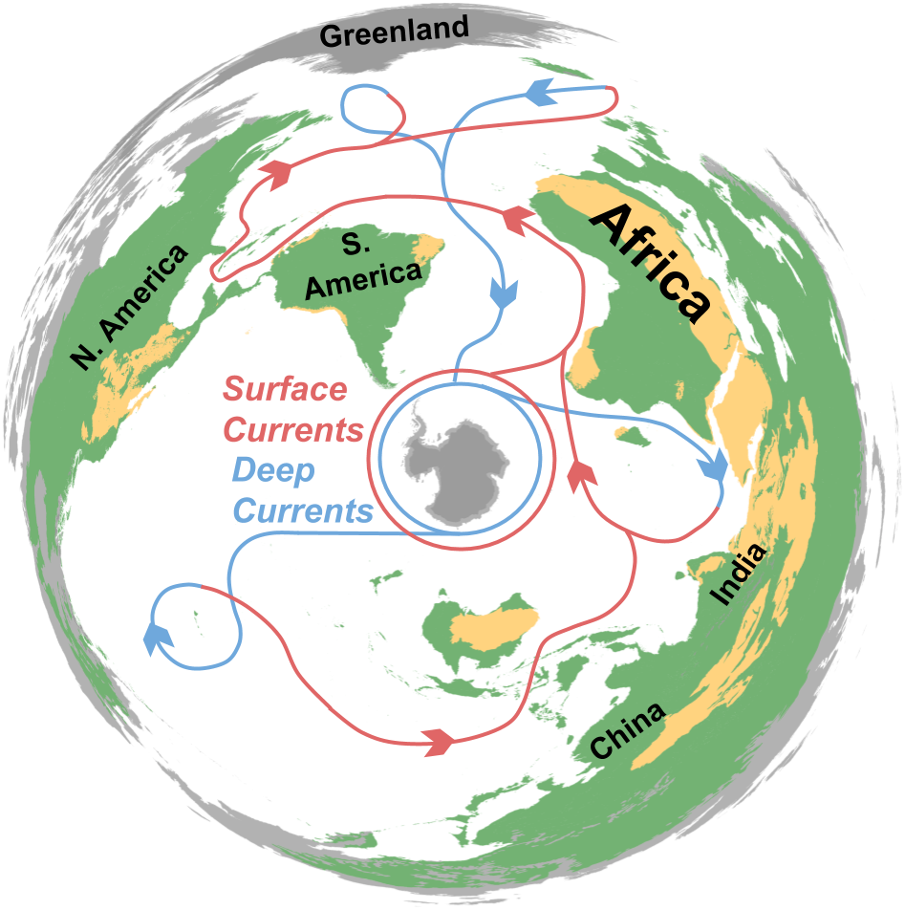

Glossary
Adhesion | The property of water that causes it to be attracted to other substances. Also see cohesion.
Amplitude | The vertical height of a wave, from trough to crest. Also see wavelength.
Axis of Rotation | Earth’s circular movement occurs around an imaginary line called its axis of rotation. Earth completes its eastward rotation once every 24 hours.
Beach Grass | Natural barriers preventing shoreline erosion.
Biomes | Ecological areas, communities of plants and animals, spanning continents with similar climates, geology, and topography. Tropics, tundra, deserts, grassland, deciduous forest, and boreal forest are Earth’s major biomes.
Cohesion | The property of water that causes it to be attracted to water. Also see adhesion.
Currents | The continuous movement of water due to waves, wind, temperature differences, density differences, Earth’s rotation, and tidal changes.
Deserts | Barren landscapes with little precipitation. Also see biomes.
Erosion | Removal of sediment by water, wind, or other natural phenomena. In the case of this unit, students explore shoreline erosion by waves and tides.
Equator | Imaginary circle around Earth, perpendicular to the planet’s axis of rotation.
Global Conveyor Belt | Worldwide circulation of ocean water due to differences in temperature and salinity, also called thermohaline circulation.
Hurricane | A rotating storm system with winds at least 119 km/h (64 knots) formed in tropical climates and strengthened over warm water.
Ocean Mechanics | The atmospheric, hydrologic, and geologic processes contributing to ocean physics such as winds, waves, and currents.
Poles | The two point at opposite ends of Earth’s axis of rotation. Earth’s poles, covered in ice caps, receive less exposure to the sun than the rest of the planet’s surface.
Sea Level | The average height of Earth’s ocean.
Sediment | Natural material broken down by natural processes, such as weathering and erosion, and transported by water or wind.
Shoreline | Land geologically modified over time by the body of water at its edge.
Storm Surge | Temporary sea level rise due to atmospheric changes.
Thermocline | The dramatic decrease in temperature between ocean layers.
Trade Winds | Perpetual winds moving toward the equator from the northeast in the northern hemisphere and the southeast in the southern hemisphere. Air pressure and temperature differences, along with Earth’s rotation, create this movement.
Tropics | Region surrounding Earth’s equator exposed to plentiful sunlight and precipitation. Tropics take up 3% of Earth’s surface, but account for 50% of its biological variation. Also see biomes.
Tundra | Biome with little tree growth due to low temperatures and short seasons. Also see biomes.
Waves | The movement of energy through water.
Wavelength | The distance from wave crest to wave crest. Also see amplitude.

Elementary Unit 1, Lesson 1 | Shoreline Erosion
  - 6E Lesson Plan and Teacher Prep

Instructor:
Grade/Class:

Overview | Lesson, Unit, Alignments
Driving Question: What properties of water contribute to shoreline erosion?
Abstract: This lesson introduces students to the properties of water and erosion via the exploration of three hands-on activities: (1) water walks, (2) penny adhesion, and (3) shoebox erosion.
Lesson Objectives: TSWBAT (1) identify and explain erosion, (2) model the cohesive and adhesive properties of water, and (3) evaluate the impacts of erosion.
Time: 120 minutes
Materials:
- Moderate weather and a schoolyard  - Internet access and a projector  - Water  - Plastic pipettes  - Spray bottles  - Pennies | - Dulled toothpicks  - Paperclips  - Pencils and paper  - A small recycled plastic food containers filled with sand and/or soil  - A recycled plastic bottle

Ocean Literacy Principles: OLP-1 The Earth has one big ocean with many features; OLP-2 The ocean and life in the ocean shape the features of Earth.
NGSS Crosscutting Concepts: (1) Patterns; (4) Systems and system models; (5) Energy and matter
NGSS Practices: (1) Asking questions; (6) Constructing explanations; (7) Engaging in argument from evidence
NGSS Performance Expectation: 4-ESS2-1 Make observations and/or measurements to provide evidence of the effects of weathering or the rate of erosion by water, ice, wind, or vegetation.

Preparation
Time: 15 minutes
Materials: a recycled plastic food container, sand and/or soil
Before beginning this lesson, prepare the shoebox erosion kit for the Elaboration section. To do this, fill a small plastic bin with sand and/or soil, creating various landforms, such as beaches or mountains, including high points. You will be pouring water over this model so your students can observe erosion in action, particularly where the soil meets the plastic edges.
Note: You can also prepare multiple models to compare the erosion of different soils or sands.

Engage | Cliff Erosion
Time: 5 minutes
Materials: Internet access and a projector
Use one of the following news clips about coastal erosion to engage your students:
- ABC News (2016), “Eroding Cliffs Threaten Residences Along the California Coastline”: http://bit.ly/2oGzpbE
- CBS This Morning (2016), “Cliff erosion threatens to push California homes into sea”: http://bit.ly/2oFhQJY
- NBC News (2016), “Cliffside Homes Near Collapse in California Due to El Niño Erosion”: http://bit.ly/1TvUcYb
Note: The video links above direct you to YouTube. If your school blocks this site, use the images from US Climate Resilience Toolkit to engage your students via this link: https://toolkit.climate.gov/topics/coastal-flood-risk/coastal-erosion. If this site is also blocked, a Google Image search of “cliff erosion” or “coastal erosion” will also provide you with engagement material.

Explore | The Water Walk
Time: 30 minutes
Materials: moderate weather and a schoolyard
If it’s a nice day and you can take your students outside, have them explore their schoolyard’s watershed. Ask your students, “If it was raining, where would the water go?” Follow these steps to complete a water walk:
- Ask your students to find your schoolyard’s high point and, as a team, go to that spot.
- Now ask, “If you were water, where would you go?” Point out the permeability of the surface you’re on. “Will some water be absorbed? Or is this surface impermeable?
- Follow the paths of water around the schoolyard and identify all points of erosion. Look for places where permeable and impermeable surfaces meet (i.e. where the buildings meet the grass, along the edges of a parking lot).
- Ask students, “Why are these places eroded?”

Explain | Cohesion & Adhesion
Time: 30 minutes
Materials: water, plastic pipettes, pennies, dulled toothpicks, paperclips, pencils, paper
To explain the cohesive and adhesive properties of water, have your students conduct the following experiment based on an activity developed by the University of Hawaii’s College of Education (see References):
- Break your class into pairs or teams of three and distribute the materials.
- Challenge your students to see how many drops of water they can fit on their penny without it overflowing. Demonstrate to your students how to use the pipette.
- Have your students record the number of drops and draw what the penny looks like with the water on top.
- Once they have found the maximum drops, have them share the number with the class and calculate a class average.
- Now, have students prod the water with their dulled toothpick. Instruct them to draw and describe what happens.
- Have them repeat step 5 with a paperclip.
- When your students have completed their drawings, ask the class to share their observations.
Define cohesion and adhesion, in terms of water properties, and have your students explain the experiment using these definitions.

Elaborate | Shoebox Erosion
Time: 20 minutes
Materials: a recycled plastic food container filled with soil, spray bottles
In this section you will model erosion with your students by following these steps:
- Introduce students to the plastic container filled with soil (see Preparation).
- Spray water on top of the soil’s high point.
- Have your students make observations about the path of water and erosion where plastic meets earth.
- Ask your students to define what is happening in terms of cohesion and adhesion.

Evaluate | Beach Grass
Time: 15 minutes
Materials: Internet access and a projector
Introduce your students to sustainable efforts to mitigate and prepare for shoreline erosion using content on NOAA’s US Climate Resilience Toolkit: https://toolkit.climate.gov/topics/coastal-flood-risk/coastal-erosion.
Note: If your school blocks this site, search Google Images for “beach grass” or “estuary restoration”.

Empower | How Erosion Impacts You
Time: 20 minutes
Context Setting for Action Plan: Have your students devise a plan to mitigate erosion in their schoolyard. Introduce them to green solutions (i.e. strategically planning trees) and coauthor a class proposal.
This section prepares students to conduct an issue investigation and create an action plan at the conclusion of this ocean literacy program.

References
“Activity: Cohesion and Adhesion.” Exploring Our Fluid Earth. Curriculum Research & Development Group, University of Hawaii: 2017.
“Cliff erosion threatens to push California homes into sea.” CBS This Morning: 2016. <http://bit.ly/2oFhQJY>
“Cliffside Homes Near Collapse in California Due to El Niño Erosion.” NBC News: 2016. <http://bit.ly/1TvUcYb>
“Coastal Erosion.” US Climate Resilience Toolkit. NOAA’s Climate Program Office. <https://toolkit.climate.gov/topics/coastal-flood-risk/coastal-erosion>
“Eroding Cliffs Threaten Residences Along the California Coastline.” ABC News: 2016. <http://bit.ly/2oGzpbE>
“Shoreline Erosion.” Educational Passages. <http://educationalpassages.com/sustainability/shoreline-erosion>

Elementary Unit 1, Lesson 2 | Waves
  - 6E Lesson Plan and Teacher Prep

Instructor:
Grade/Class:

Overview | Lesson, Unit, Alignments
Driving Question: What are the properties of ocean waves and where do they come from?
Abstract: Students activate their knowledge of shoreline erosion through the exploration of ocean waves. A hands-on activity and illustration of diagrams, introduce classrooms to the properties of waves.
Lesson Objectives: TSWBAT (1) model a wave, (2) draw and explain wavelength and amplitude, and (3) explain the relationship between wind and waves.
Time: 90 minutes
Materials:
- Transparent recycled bottles with their caps  - Cooking oil  - Water | - Blackboard or whiteboard and chalk or dry-erase markers  - Internet access and a projector  - Blue food dye/coloring

Ocean Literacy Principles: OLP-1 The Earth has one big ocean with many features; OLP-2 The ocean and life in the ocean shape the features of Earth; OLP-3 The ocean is a major influence on weather and climate.
NGSS Crosscutting Concepts: (1) Patterns; (4) Systems and system models; (5) Energy and matter
NGSS Practices: (1) Asking questions; (6) Constructing explanations; (7) Engaging in argument from evidence
NGSS Performance Expectation: 4-PS4-1 Develop a model of waves to describe patterns in terms of amplitude and wavelength and that waves can cause objects to move.

Preparation
Time: 5 minutes
Materials: transparent recycled bottles with their caps, cooking oil, water, blue food coloring/dye
To prepare for this lesson, you will be creating wave bottles, tools derived from the “Make Waves in a Bottle” Education.com activity (see References).
- Fill the bottle halfway with water.
- Dye the water blue and shake the bottle to mix the color.
- Fill the rest of the bottle with cooking oil.
- Gently rock the bottle back-and-forth. You should blue water waves slowly moving through the oil as you rock the model. If you do not see this motion, adjust the levels of oil and water as needed.

Engage | Shoreline Waves
Time: 5 minutes
Materials: Internet access and a projector
Knowledge Activation: Ask students to recall the previous lesson, Shoreline Erosion, and to explain coastal erosion.
After reviewing erosion, show students this drone footage taken by UNSW Australia’s Water Research Laboratory: http://bit.ly/2oIWeeK.

Explore | Lesson in a Bottle
Time: 25 minutes
Materials: wave bottles (see Preparation)
Break your class into pairs or teams of three and distribute the wave bottles. Instruct your class to gently rock the model back-and-forth, watch the movement of the blue water through the oil, and record their observations.

Explain | Measuring Waves
Time: 15 minutes
Materials: whiteboard or blackboard, dry-erase markers or chalk
Ask your students, “Were all of the waves in your bottle the same size?” After fielding answers draw the following diagram on the board.
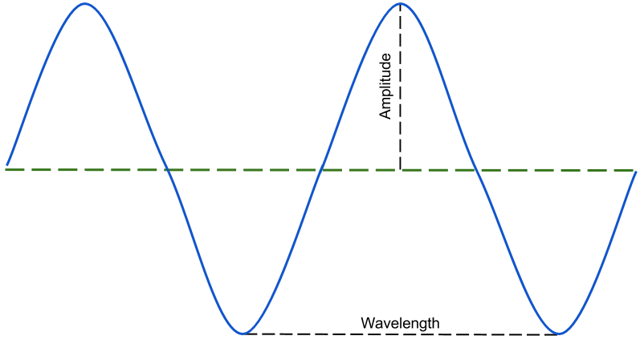
Review the terms wavelength and amplitude. Ask your students, “How do you think wavelength and amplitude affect the movement of an object in the ocean?”

Elaborate | Breaking Waves
Time: 20 minutes
Materials: Internet access and a projector, whiteboard or blackboard, dry-erase markers or chalk, paper, colored pencils
Ask students, “Where do waves end?” And, “What happens to wavelength and amplitude as the waves reach the shore?”
After fielding answers, show your students one of the following surfing videos by GoPro:
- Namibia (2016): http://bit.ly/2plf53E
- Western Australia (2014): http://bit.ly/1jxJyQY
- Tahiti (2016): http://bit.ly/2oJc8WG
Now ask, “Can you surf at any beach? Do some beaches have better waves?”
Use the diagram below for this activity.
Follow these steps with your class:
- Distribute the paper and colored pencils.
- Draw the shore and sea level on the board and instruct your students to draw the shore on their paper.
- Ask, “What do you predict will happen to the wavelength and amplitude as they waves reach the shore?” Instruct them to add waves to their drawing and identify changes to wave properties.
- Have your students share their predictions.
- Now, following the diagram above, add waves, wavelength, and amplitude to your drawing on your board.

Evaluate | Making Waves
Time: 10 minutes
Materials: Internet access and a projector
Ask, “What determines the wavelength and amplitude of ocean waves?” After a brief discussion, ask, “Do waves change when there’s a hurricane or storm?”
Show your students the following video from National Geographic: http://bit.ly/2ovUTNe.

Empower | Preparing for Storm Surge
Time: 15 minutes
Context Setting for Action Plan: Ask students to devise a way to prepare coastal communities for the dangers of storm surge. Ask how the Coast Guard or National Oceanographic and Atmospheric Administration (NOAA) could monitor waves.

References
“Drone footage of severe coastal erosion on Sydney’s Northern Beaches.” Water Research Laboratory, UNSW Australia: 2016. <http://bit.ly/2oIWeeK>
“GoPro: Kelly Slater and Dolphins Surf The Box.”<http://bit.ly/1jxJyQY>
“GoPro Awards: Surfing Tahiti With Leif Engstrom.” GoPro: 2016. <http://bit.ly/2oJc8WG>
“GoPro Surf: Best Wave of 2016 Featuring Anthony Walsh.” GoPro: 2016. <http://bit.ly/2plf53E>
“Make Waves in a Bottle.” Education.com. <www.education.com/activity/article/surf_in_a_bottle/>
“Storm Surge.” National Geographic: 2007. <http://bit.ly/2ovUTNe>

Elementary Unit 1, Lesson 3 | Trade Winds
  - 6E Lesson Plan and Teacher Prep

Instructor:
Grade/Class:

Overview | Lesson, Unit, Alignments
Driving Question: How does the uneven heating of Earth contribute to the creation of surface winds?
Abstract: Students explore temperature’s relationship to surface wind through two phenomena demonstrations and two prediction activities.
Lesson Objectives: TSWBAT (1) identify Earth’s major biomes, (2) explain temperature’s role in creating surface winds, and (3) apply knowledge of biomes and wind to ocean mechanics.
Time: 90 minutes
Materials:
- Desk fan  - Plastic bin  - Water  - A small buoyant object (i.e. rubber duck) | - Hot plate  - Glass beaker  - Colored pencils  - Internet access and a projector
Student Pages: Atlantic and Pacific prediction maps
Ocean Literacy Principles: OLP-3 The ocean is a major influence on weather and climate; OLP-2 The ocean and life in the ocean shape the features of Earth.
NGSS Crosscutting Concepts: (1) Patterns; (4) Systems and system models; (5) Energy and matter
NGSS Practices: (1) Asking questions; (6) Constructing explanations; (7) Engaging in argument from evidence
NGSS Performance Expectation: 3-ESS2-2 Obtain and combine information to describe climates in different regions of the world.

Preparation
Time: 20 minutes
Materials: desk fan, plastic bin, water, a small buoyant object (i.e. rubber duck)
There are two items needing preparation before this lesson: (1) a wind simulator and (2) access to web applications.
This lesson’s Engagement section begins with the display of a wind simulator. Fill a plastic bin with water and have a desk fan blowing nearby, creating small waves on the water’s surface. Test the buoyant object on the water to be sure the waves are strong enough to move it across the bin. Have this on display as students walk into the classroom.
This lesson uses several web applications to engage students: NGSS Apps and Nullschool Earth (see References). Although these websites are not required to teach this lesson, they are highly recommended. The sites may be blocked on your school’s network. Put in a request to unblock them prior to implementing this lesson plan. Below are the sites URLs:
- Exploring Biomes (for Explore): http://arcg.is/2pdQYDQ
- Countries and Their Biomes (for Explore): http://arcg.is/2q6oPiH
- Exploring the Tropics (for Explore): http://arcg.is/2qwG2CV
- Nullschool Earth (for Evaluate): https://earth.nullschool.net/

Engage | Surf’s Up
Time: 10 minutes
Materials: wind simulator (see Preparation), a small buoyant object
Knowledge Activation: Have the wind simulator on display when your students walk into the classroom. Place a small buoyant object in the water and ask, “What’s moving this object?”

Explore | The Equator
Time: 20 minutes
Materials: printed Atlantic and Pacific prediction maps (see Appendix), colored pencils
Distribute the maps and colored pencils. Ask your students to color the following biomes: (1) deserts, (2) tropics, and (3) tundra.
If your students have learned about biomes in a previous class, use this opportunity to activate their knowledge on the subject. If this is your class’s first exposure to biomes, use one of the following NGSS Apps (see References) or a map of Earth’s biomes to guide the Exploration.
- Exploring Biomes: http://arcg.is/2pdQYDQ
- Countries and Their Biomes: http://arcg.is/2q6oPiH
- Exploring the Tropics: http://arcg.is/2qwG2CV
After your students have colored and discussed their maps, ask, “Why does Earth have biomes?” After fielding answers, “Is all of our planet exposed to the same amount of sunlight?”

Explain | Temperature Movement
Time: 10 minutes
Materials: hot plate, glass beaker, water
Ask, “What happens to air when it warms?”
Knowledge Activation: Ask, “What happens when you boil water?” Fill the glass beaker with water and boil the water on a hotplate. With your students observing the bubbling beaker, ask, “Where are the bubbles coming from?” After fielding answers, explain that the bubbles are warmer water rising to the surface.

Elaborate | The Equator
Time: 20 minutes
Materials: a globe (if available), blackboard or whiteboard, chalk or dry-erase markers, paper, colored pencils
Display a globe to the class, point to the North Pole, and ask, “What is the temperature here?” Ask the same question about the equator and South Pole.
Use the following diagram and steps to have students evaluate the lesson:
The steps below guide this activity:
- Draw a globe on the board and write “cold” at the poles and “warm” at the equator and instruct your students to do the same.
- Ask, “If the air cold at the poles and warm at the equator, where will the air move?” After discussing, draw arrows from the equator to poles.
- Now, ask, “What about air pressure? Where is the air pressure higher?”
- Knowledge Activation: Write “high” at the poles and “low” at the equator and ask, “Where will the air move?”
After discussing, draw arrows from the poles to the equator.

Evaluate | Predict the Wind
Time: 20 minutes
Materials: printed Atlantic and Pacific prediction maps (see Appendix), colored pencils, Internet access, projector
Have your class return to their prediction maps (or give them fresh maps) and ask them to predict where the ocean winds will travel. Instruct them to draw warm winds in one color and cold winds in another.
Once they have completed their predictions, show them Nullschool Earth by using the following link: https://earth.nullschool.net/. The default view shows Earth’s winds. Explore the application in front of the class and ask your student to evaluate their predictions.

Empower | Wind & Waves
Time: 10 minutes
Context Setting for Action Plan: Ask your class, “If you worked for the Coast Guard and were planning a rescue mission, what ocean mechanics would you need to prepare for?” After fielding answers, ask, “How can we measure ocean waves and winds?”

References
Beccario, Cameron. “Earth.” <https://earth.nullschool.net/>
“NGSS App: Countries and Their Biomes.” Washington College Center for Environment & Society (CES): 2016. <http://arcg.is/2q6oPiH >
“NGSS App: Exploring Biomes.” Washington College CES: 2016. <http://arcg.is/2pdQYDQ>
“NGSS App: Exploring the Tropics.” Washington College CES: 2016. <http://arcg.is/2qwG2CV>

Elementary Unit 1, Lesson 4 | Currents
  - 6E Lesson Plan and Teacher Prep

Instructor:
Grade/Class:

Overview
Driving Question: What are the mechanics behind ocean currents?
Abstract: Students model the thermocline and use a data-driven application to explore ocean currents.
Lesson Objectives: TSWBAT (1) map major ocean currents, (2) model the thermocline and explain its role in water transportation, and (3) predict the trajectory of a macroscopic object exposed to ocean currents.
Time: 90 minutes
Materials:
- Water  - Microwave or hotplate  - Red dye  - Reusable towels  - Transparent plastic bins with a recommended length between 38 and 50 cm (15 and 20 inches) | - Transparent plastic cups or recycled water bottles  - Scissors  - Tape  - Pitcher  - Paper and colored pencils  - Internet access and projector
Student Pages: Atlantic and Pacific prediction maps
Ocean Literacy Principles: OLP-2 The ocean and life in the ocean shape the features of Earth; OLP-3 The ocean is a major influence on weather and climate.
NGSS Crosscutting Concepts: (1) Patterns; (4) Systems and system models; (5) Energy and matter
NGSS Practices: (1) Asking questions; (6) Constructing explanations; (7) Engaging in argument from evidence
NGSS Performance Expectation: 5-ESS2-1 Develop a model using an example to describe ways the geosphere, biosphere, hydrosphere, and/or atmosphere interact.

Preparation
Time: 20 minutes
Materials: water, a transparent plastic bin, transparent plastic cups, scissors, tape, small weights (i.e. marbles, rocks, coins), red dye, pitcher, printer
To prepare for this lesson, three items must be completed: (1) create the display model, (2) fill the water pitchers, (3) prepare plastic cups, (4) print the prediction maps (see Appendix), and (5) unblocking the Educational Passages website.
Create the display model for the Exploration activity based on the Exploring Our Fluid Earth activity from the University of Hawaii (see References). Use the materials list above and the following modified diagram to create the display.
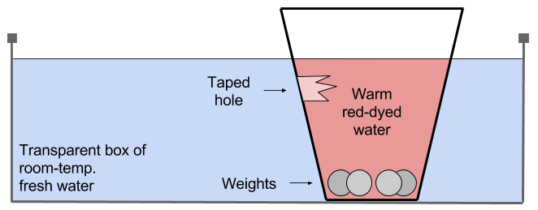
After creating the display, fill a pitcher with hot water warmed on a hotplate or in a microwave. Dye the water red. This is the water you will pour into your students’ cups in the Exploration activity.
Prepare the plastic cups by poking a hole below the water line.
Print the prediction maps and put in a request to unblock Educational Passages prior to implementing this lesson plan: http://educationalpassages.com/active-boat-map/.

Engage | The EAC
Time: 10 minutes
Materials: Finding Nemo the film
If you have access to the Disney animated film, Finding Nemo, show your students the Eastern Australian Current scene where the turtles are riding a major ocean current. Ask students, “What makes ocean currents?”
Knowledge Activation: Ask, “What happens to water when it’s boiled? Where do the ‘bubbles’ come from?” Revisit the previous lesson, Trade Winds, and the activities exploring temperature movement.

Explore | Equatorial Currents
Time: 25 minutes
Materials: paper, colored pencils, transparent plastic bins, prepared plastic cups, tape, small weights (i.e. marbles, rocks, coins), pitcher of warmed red-dyed water (see Preparation)
To have your students explore temperature’s effect on water flow, use the following steps to complete part of the Exploring Our Fluid Earth activity.
- Break your class into pairs or teams of three and distribute paper, colored pencils, a plastic bin, two prepared plastic cups, and tape to each team.
- Instruct the teams to patch the plastic cup holes with tape, add weight to the bottom of the cups, and fill the bin with tap water.
- Go to each group; fill their plastic cup with warmed red-dyed water.
- Instruct the group to place the cup near the edge of their bin with the tape facing the opposite wall (see Preparation). Have the students sketch the model and draw their predictions as to where the water will move.
Once step 4 is completed for every group, have all teams carefully remove the tape from the plastic cups and record their observations.

Explain | Thermocline
Time: 10 minutes
Materials: paper, colored pencils
After reviewing the previous activity’s results, draw or display the following diagram.
Ask students to explain the graphic.

Elaborate | Current Hunting
Time: 20 minutes
Materials: Atlantic and Pacific prediction maps (see Appendix), colored pencils
Knowledge Activation: Distribute prediction maps to your students and instruct them to illustrate the movement of heat around the ocean. Have them identify the equator and, using two different colors (one for warm water and a second for cold).
Draw or display the following graphic of the global conveyor belt.

Evaluate | Drifters
Time: 15 minutes
Materials: used Atlantic and Pacific prediction maps, Internet access, projector
Ask your students, “How can we evaluate the accuracy of the map?”
After fielding answers, introduce your students to an Educational Passages mini-boat, either in person or in an image. The boats drift around the ocean and can be tracked using the following URL: http://educationalpassages.com/active-boat-map/. Project the active boat map on your board. Ask them to evaluate their predictions.
Knowledge Activation: Ask, “Are winds, waves, or currents moving the boats?”

Empower | Your Educational Passage
Time: 10 minutes
Context Setting for Action Plan: If you have access to a mini-boat, ask your students where they think the boat should be launched. Have them explain their ideas. Ask, “What can we gain from launching a mini-boat?”

References
“Activity: Modeling Thermohaline Water Flow.” Exploring Our Fluid Earth. Curriculum Research & Development Group, University of Hawaii: 2017. <http://bit.ly/2q2BTTR>
Finding Nemo. Disney Pixar: 2003.

