Middle School Unit 1| Ocean Mechanics
  - Unit Overview

Unit Goals
Big Idea: What are the mechanics behind ocean physics?
Abstract of Included Lessons: In this Earth Science unit, Middle School students explore the celestial, atmospheric, and geological mechanics behind ocean physics. In the first lesson, The Earth-sun-moon System, students evaluate the system’s impact on ocean mechanics. Then, they explore the impact of Earth’s rotation on surface winds and currents in the following computer lab activity, Modeling Weather. Students explore and evaluate a data-based atmospheric and oceanic application to explain the relationship between pressure gradients, wind, and currents. Students then elaborate upon these concepts by modeling upwelling and downwelling in a lesson on Thermohaline Circulation. In the final lesson, Sea Level Rise, students evaluate changes in ocean mechanics.
Ocean Literacy Principles:
- The Earth has one big ocean with many features.
- The ocean and life in the ocean shape the features of Earth.
- The ocean is a major influence on weather and climate.
NGSS Crosscutting Concepts: (1) Patterns; (4) Systems and system models; (5) Energy and matter
NGSS Practices: (1) Asking questions; (6) Constructing explanations; (7) Engaging in argument from evidence

Contents
Item  Unit Overview  Explanation and Glossary  Lesson 01 | The Earth-sun-moon System  Lesson 02 | The Coriolis Effect  Lesson 03 | Modeling Weather  Lesson 04 | Thermohaline Circulation  Student Pages | Pages  1  2 through 9  10 through 13  14 through 17  18 through 23  24 through 29  30 and 31

Middle School Unit 1 | Ocean Mechanics
  - Explanation and Glossary

Ocean Mechanics Explanation
In this Earth Science unit, students explore the celestial, atmospheric, and hydrologic phenomena responsible for ocean mechanics and the impact of these mechanics on other Earth processes.
Middle school students begin this unit by exploring Earth’s relationship with the sun and moon. The Earth-sun-moon system directly influences ocean mechanics. Shown in Figure 1.01, the Earth takes 365 days to orbit the sun while the moon completes its orbit every 27 days. Earth’s position relative to the sun and moon changes due to its spin around an axis of rotation. Earth completes a full rotation around this imaginary line every 24 hours. These cycles result in seasonal and tidal changes. To understand the latter, students must understand the properties of water.
Water is both cohesive, in that water molecules attract other water molecules, and adhesive, in that water molecules are attracted to other substances. In both cases, positively charged hydrogen atoms and negatively charged oxygen atoms, seen in Figure 1.02, create molecular bonds responsible for this attraction. Due to water’s cohesive nature, the gravitational pull of the moon and sun cause temporary worldwide sea level rise, known as tidal bulges. Although the moon’s tidal bulge is stronger due to its proximity to Earth, the sun’s tidal bulge can offset its effects. Significantly higher tides, spring tides, occur when the sun and moon are on the same plane while significantly smaller tides, neap tides, occur when the sun and moon form a 90° angle. Tidal bulges, depicted in Figure 1.03, also occur due to the centrifugal force caused by Earth’s rotation. This force continually acts upon the entire ocean, but is disrupted by the gravitational pull of the sun and moon. In the diagram, these bulges can be seen on the side of Earth opposite each celestial body. The sun and moon displace water on their side of Earth, while the centrifugal force displaces water untouched by their gravity.
As mentioned, while Earth orbits the sun, it spins around an axis of rotation. The movement creates a phenomenon called the Coriolis Effect. As seen Figure 1.04, warm air moving from the equator to Earth’s cold poles bends eastward, north of the equator, and westward, south of the equator. This impacts the trajectory of surface winds that, in turn, affect the motion of the ocean’s currents. Winds occur in the presence of pressure gradients where air moves from one isobar to the next. Pressure gradients are created by differences in atmospheric pressure. The uneven heating of Earth’s surface is a primary factor contributing to this phenomenon. Warm air rises while colder, denser air sinks. The friction of air moving across the ocean creates waves and surface currents. Surface currents in the open ocean form large gyres, identified in Figure 1.05, and are part of a larger process of ocean water movement, thermohaline circulation.
Thermohaline circulation is the worldwide movement of ocean water due to differences in temperature and salinity. The warmer surface water moves from the equator to the poles where it cools, becomes denser, and sinks. This process is called downwelling. Cold water near the poles has higher salinity due to the salt remaining after some water freezes. The colder, denser water then moves toward the equator where it undergoes upwelling: warming, losing its salinity, and rising. Figure 1.06 illustrates this process. Worldwide ocean water circulation, depicted in Figure 1.07, is commonly known as the global conveyor belt.
The ocean is under a constant state of change. As Earth’s average temperature continues to rise, glacial ice will melt and water molecules will undergo thermal expansion. Both factors contribute to eustatic sea level rise, an increase of the global mean sea level. Sea level rise fluctuates at the local level as well. Glacial isostatic adjustment is a primary factor contributing to regional sea level rise. Also know as post-glacial rebound and depicted in Figure 1.08, this phenomenon occurs when continental plates readjust to pre-glacial heights after glacial ice melts. This process affects regions disproportionately. As certain areas of continental crust uplift, other areas will subside. Additional subsidence, caused by ground resource withdrawal, can increase the impact of sea level rise.
To set the context for student-led action planning, this unit links ocean mechanics and society. For coastal communities, tidal changes may directly impact local livelihoods. Tracking tidal changes and gradual sea level rise could be of interest to your students. These phenomena impact storm surges damaging property and posing a danger to affected communities. On a broader scale, students may be interested in the impact of glacial melt on thermohaline circulation and the impact of thermohaline slowdown on other ocean processes.

Appendix
Figure 1.01 | The Earth-sun-moon System
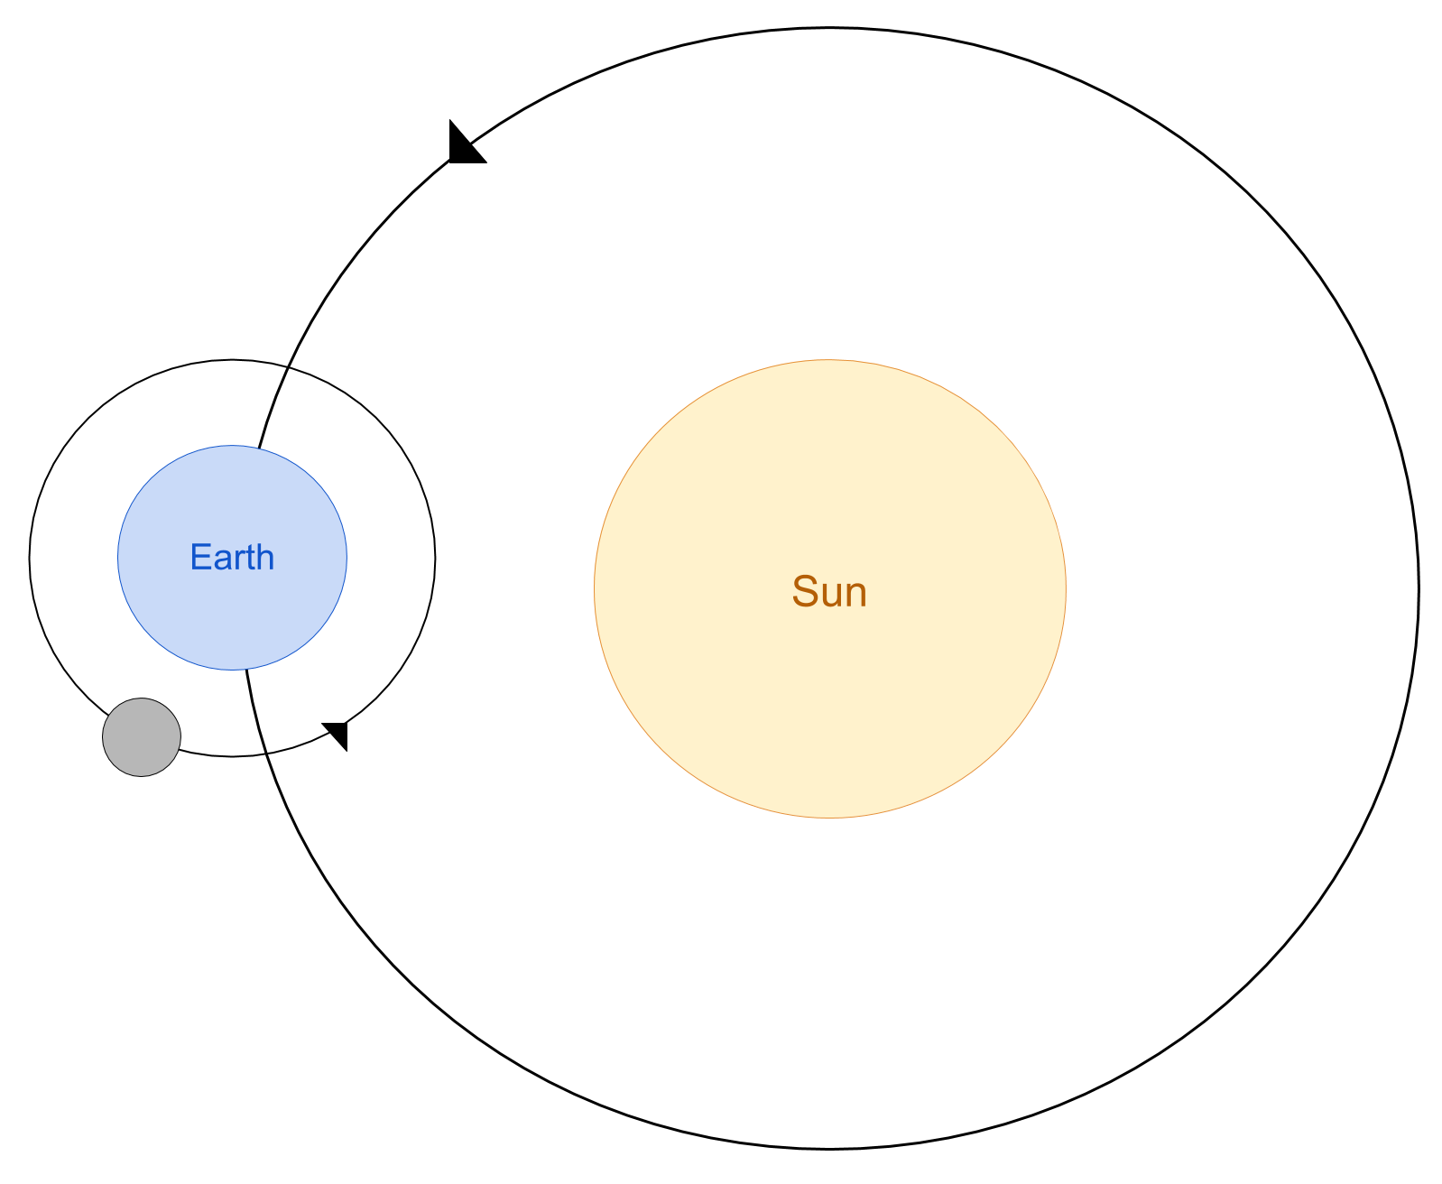
Figure 1.02 | Water Molecule
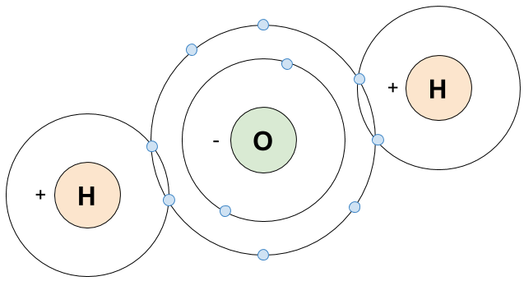

Figure 1.03 | Tidal Bulges
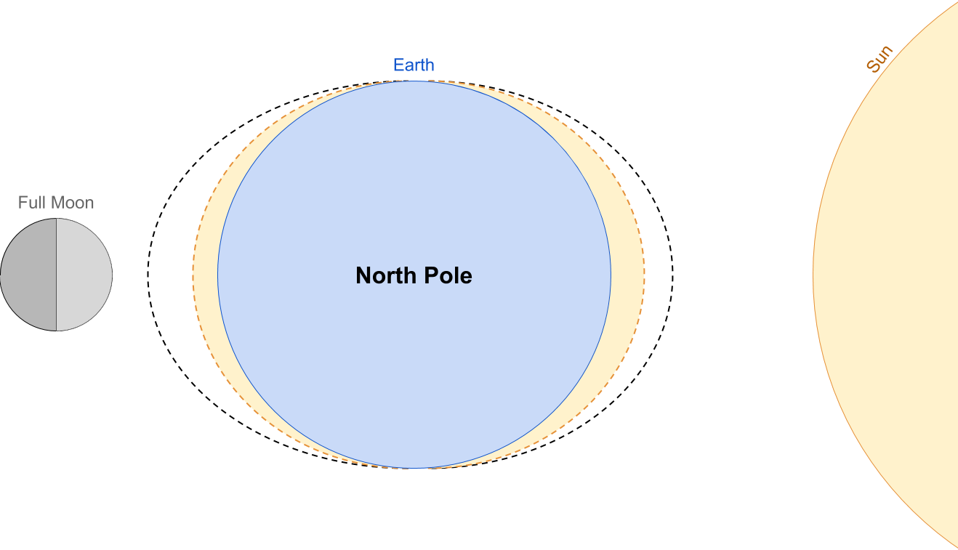
Figure 1.04 | The Coriolis Effect
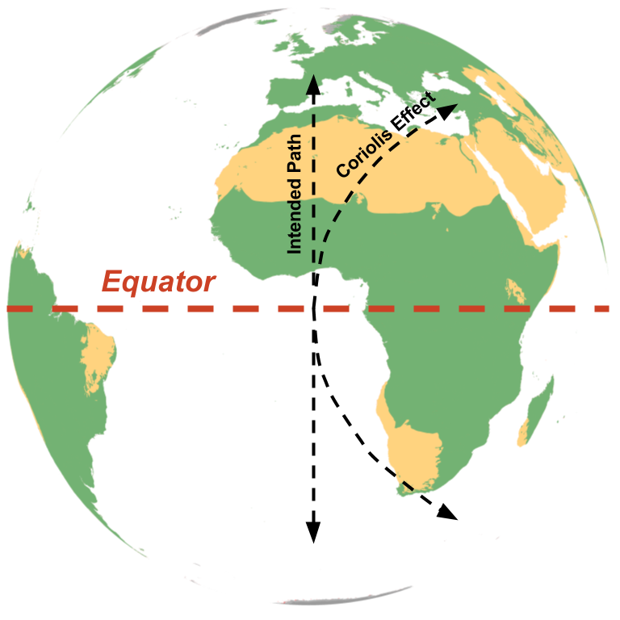

Figure 1.05 | Major Ocean Currents
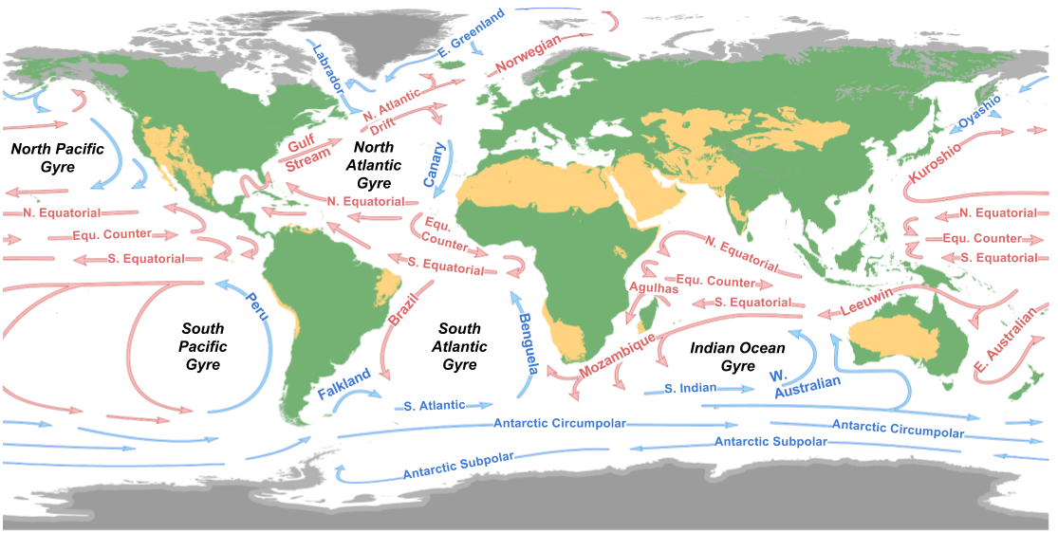
Figure 1.06 | Upwelling
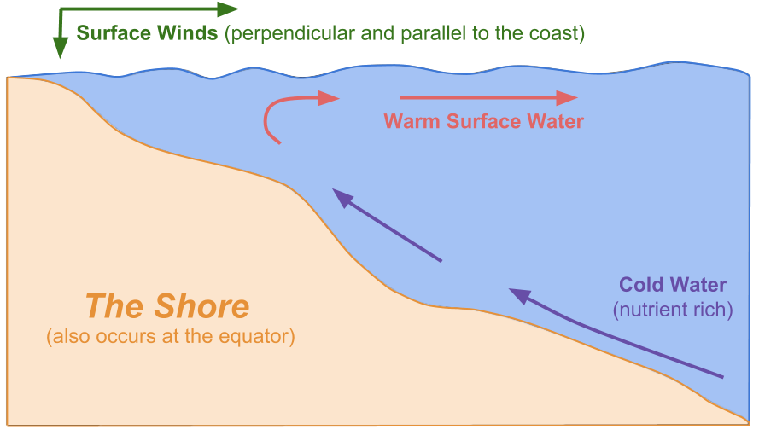

Figure 1.07 | The Global Conveyor Belt
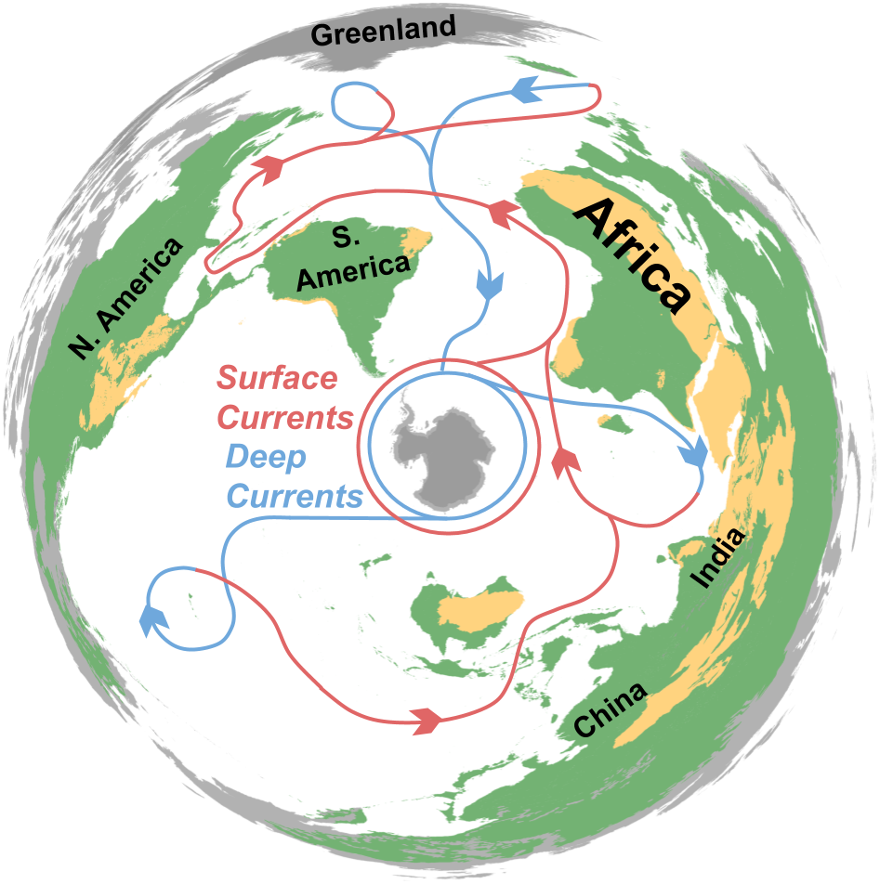
Figure 1.08 | Glacial Isostatic Adjustment

Glossary
Adhesion | The property of water that causes it to be attracted to other substances. Also see cohesion.
Atmospheric Circulation | The worldwide movement of air largely due to celestial mechanics, influencing ocean current circulation.
Atmospheric Pressure | Weight of the atmosphere on Earth’s surface modified by temperature variation, among other factors.
Axis of Rotation | Earth’s circular movement occurs around an imaginary line called its axis of rotation. Earth completes its eastward rotation once every 24 hours.
Celestial Mechanics | The processes responsible for the movement of celestial objects such as Earth, the sun, and moon.
Centrifugal Force | Force directed away from an object spinning around an axis of rotation.
Cohesion | The property of water that causes it to be attracted to water. Also see adhesion.
Coriolis Effect | Deflection of a motion across Earth’s surface due to the planet’s rotation. Motion north of the equator bends eastward, while motion south of the equator bends westward.
Currents | The continuous movement of water due to waves, wind, temperature differences, density differences, Earth’s rotation, and tidal changes.
Downwelling | The movement of surface water downwards due to temperature or density changes, or other processes along shorelines. Also see upwelling.
Earth-sun-moon System | The movement of Earth, its moon, and the sun in relation to each other and their gravitational forces.
Erosion | Removal of sediment by water, wind, or other natural phenomena. In the case of this unit, students explore shoreline erosion by waves and tides.
Equator | Imaginary circle around Earth, perpendicular to the planet’s axis of rotation.
Global Conveyor Belt | See thermohaline circulation.
Gyres | Systems of continuous surface winds and currents in the open ocean.
Hurricane | A rotating storm system with winds at least 119 km/h (64 knots) formed in tropical climates and strengthened over warm water.
Isobar | A cartographic line used to show where air pressure is the same.
Neap Tide | Significantly smaller tides occurring when the sun and moon form a 90° angle. Also see spring tides.
Ocean Mechanics | The atmospheric, hydrologic, and geologic processes contributing to ocean physics such as winds, waves, and currents.
Poles | The two point at opposite ends of Earth’s axis of rotation. Earth’s poles, covered in ice caps, receive less exposure to the sun than the rest of the planet’s surface.
Salinity | Percentage of salt dissolved in a body of water. Freshwater has 0 to 0.5 parts per thousand (ppt); brackish water has 0.5 to 30 ppt; and seawater has 30 to 50 ppt. Water with a higher salinity is denser and plays an essential role in thermohaline circulation.
Sea Level Rise | The increase in the sea level’s height relative to its average height at given point in time. This rise can be temporary or long term, and regional or eustatic.
Sediment | Natural material broken down by natural processes, such as weathering and erosion, and transported by water or wind.
Shoreline | Land geologically modified over time by the body of water at its edge.
Spring Tide | Significantly higher tides occurring when the sun and moon are on the same plane. Also see neap tides.
Storm Surge | Temporary sea level rise due to atmospheric changes.
Surface Currents | The movement of water up to 10 meters below the ocean surface. The maximum velocity of these currents occurs at the surface due to the friction of wind.
Thermocline | The dramatic decrease in temperature between ocean layers.
Thermohaline Circulation | The worldwide movement of ocean water due to differences in temperature and salinity, commonly referred to as the global conveyor belt.
Thermohaline Slowdown | The potential slowing of thermohaline circulation due to glacial melt. As polar ice melts, salinity drops, weakening the movement of water around the world.
Tidal Bulge | Temporary worldwide sea level rise due to the gravitational pull of the moon and sun, and the centrifugal force of Earth’s rotation.
Trade Winds | Perpetual winds moving toward the equator from the northeast in the northern hemisphere and the southeast in the southern hemisphere. Air pressure and temperature differences, along with Earth’s rotation, create this movement.
Upwelling | The movement of surface water upwards due to temperature or density changes, or other processes along shorelines. Also see downwelling.
Waves | The movement of energy through water.

Middle School Unit 1, Lesson 1 | The Earth-sun-moon System
  - 6E Lesson Plan and Teacher Prep

Instructor:
Grade/Class:

Overview
Driving Question: What roles do the sun and moon play in ocean mechanics?
Abstract: Students model the Earth-sun-moon system and evaluate its impact on ocean mechanics.
Lesson Objectives: TSWBAT (1) model the Earth-sun-moon System, (2) explain the effects of this system on ocean mechanics, and (3) map the temporal patterns of ocean mechanics as they relate to the Earth-sun-moon system.
Time: 90 minutes
Materials:
- Small foam ball or object  - String or rope  - Screwdriver | - Blue, yellow, grey clay  - Colored pencils  - Paper

Ocean Literacy Principles: OLP-1 The Earth has one big ocean with many features; OLP-3 The ocean is a major influence on weather and climate.
NGSS Crosscutting Concepts: (1) Patterns; (4) Systems and system models; (5) Energy and matter
NGSS Practices: (1) Asking questions; (6) Constructing explanations; (7) Engaging in argument from evidence
NGSS Performance Expectation: MS-ESS1-1 Develop and use a model of the Earth-sun-moon system to describe the cyclic patterns of lunar phases, eclipses of the sun and moon, and seasons.

Preparation
Time: 5 minutes
Materials: small foam ball or object, string or rope, screwdriver
Before this activity, you will need to create a centrifugal tether for the Elaboration section. To do this, use a screwdriver (or other pointed object) and poke a hole through a small foam ball or object. Feed the rope or string through the hole, pull it around the object, and tie it to itself where it entered the object. You will only need one centrifugal tether for this activity.

Engage | The Tides They Are A Changing
Time: 10 minutes
Materials: Internet and a projector
Play a video showing tidal phenomena to engage your students. Use the following links as examples:
- Tide-lapse in Nova Scotia: http://bit.ly/2pXHdtA
- Tide-lapse in Fitzgerald Marine Reserve: http://bit.ly/2qVMFuu

Explore | System Modeling
Time: 30 minutes
Materials: blue, yellow and grey clay, pencils
In this activity, groups of students will model the Earth-sun-moon System using the following steps:
- Break your class into groups of three (or pairs if necessary) and distribute a large clump of yellow clay, a medium clump of blue, and a small clump of grey.
- Instruct your students to practice modeling the Earth-moon System. Show them a diagram or video of the system such as the one below.
- Monitor your groups and, once a team has successfully demonstrated the process, have them share their demonstration with the class. Ask, “What effect does the moon have on Earth? What forces are at work?”
- Now, instruct your students to add the sun to their model.
- Monitor your groups and, once a team has successfully demonstrated the process, have them share their demonstration with the class. Ask, “How does the sun change the equation? What forces are at work?”

Explain | Tidal Bulges
Time: 10 minutes
Knowledge Activation: Ask, “How does the moon’s gravitational pull impact ocean tides?” Show or draw the following diagram and ask, “Which tidal bulge is bigger and why?”
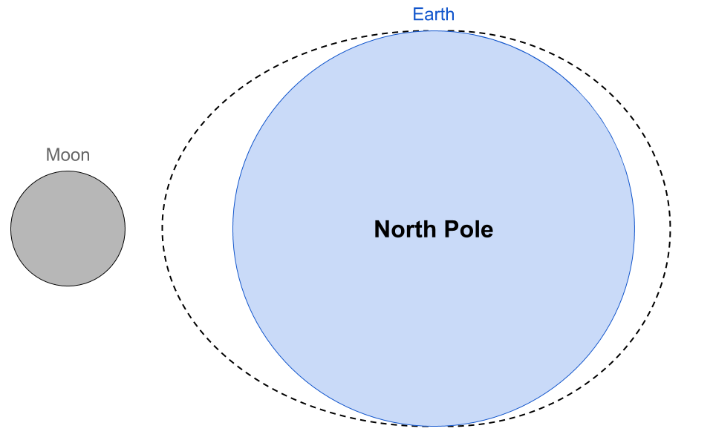

Elaborate | Centrifugal Force
Time: 10 minutes
Materials: centrifugal tether (see Preparation)
With the graphic still drawn or displayed, ask, “Why is there a second, smaller bulge on the opposite side of Earth?” After fielding answers, have a student come to the front of the class to display centrifugal force using the centrifugal tether. Have the student spin the tether around their head, illustrating centrifugal force.
After the student takes a seat, ask, “What would have happened if they had let go?” And then, “How does this help explain the small tidal bulge opposite the moon?”

Evaluate | Neap and Spring Tides
Time: 20 minutes
Materials: colored pencils, paper
Display or draw the following diagram on the board and ask, “What happens to the tidal bulges when the sun is added to the system? Are the bulges bigger or smaller?”
Distribute the paper and colored pencils and ask your students to draw the following four diagrams:
- Full moon (the diagram above)
- New moon (where the Earth, moon, and sun are on the same plane)
- The moon “above” Earth, perpendicular to the Earth-sun plane
- The moon “below” Earth, perpendicular to the Earth-sun plane
Tell your class that two of the diagrams will represent Spring tides, where the tides are highest, and the other two represent Neap tides, where the tides are lowest. Ask your students which diagrams are Spring and Neap tides.

Empower | Tide Monitoring
Time: 10 minutes
Materials: Internet and a projector
Context Setting for Action Plan: Ask, “Why would we want to track the tides?” Use pictures from NOAA’s article “Reading Between the Tides” (http://bit.ly/2pZOKsc) to introduce your students to tide monitoring stations.

References
“Bay of Fundy Tides - Halls Harbour Timelapse.” Bay of Fundy: 2010. <http://bit.ly/2pXHdtA>
Dusto, Amy. “Reading Between the Tides: 200 years of measuring global sea level.” Climate.gov. NOAA: 2014. <http://bit.ly/2pZOKsc>
Marshak, Stephen. Earth: Portrait of a Planet. Norton: 4th Ed, 2012.
“Tidal Time Lapse.” National Geographic. <http://bit.ly/2qVMFuu>

Elementary Unit 1, Lesson 2 | Modeling Weather
  - 6E Lesson Plan and Teacher Prep

Instructor:
Grade/Class:

Overview
Driving Question: How can data models reveal the relationship between surface winds and currents?
Abstract: In this computer lab activity, students explore and evaluate a data-based atmospheric and oceanic model, Nullschool Earth (https://earth.nullschool.net/), to explain the relationship between pressure gradients, wind and currents.
Lesson Objectives: TSWBAT (1) use data-driven models to construct explanations, (2) model the Coriolis Effect, (3) explain the relationship between pressure gradients, wind and currents, and (4) predict the movement of a macroscopic object exposed to surface winds and currents.
Time: 90 minutes
Materials:
- Computer lab with Internet connection  - Pieces of poster board  - Colored markers | - Blackboard or whiteboard and chalk or dry-erase markers  - Paper  - Colored pencils
Student Pages: Atlantic and Pacific prediction maps
Ocean Literacy Principles: OLP-2 The ocean and life in the ocean shape the features of Earth; OLP-3 The ocean is a major influence on weather and climate.
NGSS Crosscutting Concepts: (1) Patterns; (4) Systems and system models; (5) Energy and matter
NGSS Practices: (1) Asking questions; (6) Constructing explanations; (7) Engaging in argument from evidence
NGSS Performance Expectation: MS-ESS2-5 Collect data to provide evidence for how the motions and complex interactions of air masses results in changes in weather conditions; MS-ESS2-6 Develop and use a model to describe how unequal heating and rotation of the Earth cause patterns of atmospheric and oceanic circulation that determine regional climates.

Preparation
Materials: computer lab, projector, Internet access
In order to complete this lesson, you will need to (1) reserve your school’s computer lab or resources, (2) unblock the following sites, (3) set up your computer to engage the class, and (4) print the Educational Passages isobar and prediction maps (see Appendix).
This lesson uses Nullschool Earth, a free online application created by Cameron Beccario, and the Educational Passages active boat map to visualize ocean and climate data. The sites may be blocked on your school’s network. Put in a request to unblock them prior to implementing this lesson plan. Below are the sites URLs:
- Nullschool Earth: https://earth.nullschool.net/
- Educational Passages active boat map: http://educationalpassages.com/active-boat-map/
Before your class enters the computer lab, go to https://earth.nullschool.net/.

Engage | A Data-based Model
Time: 10 minutes
Materials: projector and Internet access
Knowledge Activation: With Nullschool Earth displayed on your projector (see Preparation), ask, “What does this model show?”
After discussing, tell your students they will use this data modeling application

Explore | Prevailing Winds
Time: 30 minutes
Materials: computer lab, a projector, Internet access
Knowledge Activation: Ask, “Why do winds move from the equator to the poles?”
Use the following steps to compare ocean currents and winds:
- Go to https://earth.nullschool.net/. The default view shows surface wind speed. Explore this layer with your students.
- In the bottom-left corner, click on ‘Earth’.
- In the pop-up window, click ‘Temp’ next to ‘Overlay’. This now shows surface wind temperature
- Explore this layer with your students and click on ‘Wind’ next to ‘Overlay’ to display wind speed again.
Knowledge Activation: Ask your students about the relationship between wind direction, speed, temperature, and air pressure. Ask, “How do the winds and temperature create ocean surface currents?”
Note: (1) If students want more information on any of the layers, such as hPa (atmospheric air pressure layers measured in hectopascal), have them click on ‘About’ in the menu’s bottom-left corner. (2) Use the following two links as shortcuts:
- Wind speed: https://earth.nullschool.net/#current/wind/surface/level
- Wind temperature: https://earth.nullschool.net/#current/wind/surface/level/overlay=temp

Explain | Coriolis Effect
Time: 10 minutes
Materials: paper, colored pencils, several pieces of poster board, colored markers, whiteboard or blackboard, dry-erase markers or chalk
After your students explore the application, ask, “What are the mechanics behind the wind?” And, “Does the wind move directly from the equator to the poles?”
Have students model the Coriolis Effect using a modified activity, originally developed by Jerry D. Roth for NOAA and NSTA (see References). This activity is broken into the following steps:
- Distribute pieces of paper and colored pencils and ask your students to predict how a straight line will be drawn on a moving piece of paper. To clarify your question, roll up a piece of poster board and turn it clockwise to simulate the movement for your class.
- Now pick two students to help with the activity.
- Spin a the poster board clockwise and have the first student practice drawing a straight line down with the back of a marker. After they’ve practiced, have them draw a straight line down while you turn the paper. If they make a mistake, try again.
- Ask your class to explain what happened. And then ask, “What will happen if I spin the paper the other way?”
- Have the second student repeat Step 3 with a different colored marker on fresh poster board, while you spin the paper counter-clockwise.
Ask your class what happened. After discussing the phenomena, draw a diagram of the Coriolis Effect such as the one included above. Ask, “Can you see this phenomena in the online data model?”

Elaborate | Gyres
Time: 10 minutes
Materials: printed Atlantic and Pacific prediction maps (see Appendix), colored pencils
Distribute the prediction maps and ask your students to draw ocean currents based on their exploration of atmospheric models.

Evaluate | The Ocean
Time: 20 minutes
Materials: computer lab with Internet access
Once they have made their predications, have your class return to https://earth.nullschool.net/. Students should use the following steps to visualize oceanic data.
- In the bottom-left corner, click on ‘Earth’.
- In the pop-up window, click ‘Ocean’ next to ‘Mode’. The default animation shows ‘Waves’. Have student explore this layer.
- Now, with ‘Ocean’ highlighted yellow, click ‘Currents’ next to ‘Animate’ and make sure ‘Currents’ is selected next to ‘Overlay’. This shows the major ocean currents and their speeds. Ask students to identify the equator and major ocean currents, such as the Gulf Stream.
Ask students to evaluate the predictions they made on their maps.

Empower | Collecting Data
Time: 10 minutes
Materials: Internet access and a projector
Context Setting for Action Plan: Ask your class where Nullschool Earth gets its data and, “How do we know if this data is accurate?”
Introduce your students to the Educational Passages active boat map: http://educationalpassages.com/active-boat-map/. Explain that schools launch small, unmanned sailboats with onboard GPS to collect oceanic data. Ask, “Does the data from Educational Passages verify the Nullschool Earth data?”
Knowledge Activation: Ask, “What forces act upon the boats?”

References
Beccario, Cameron. Earth. <https://earth.nullschool.net/>

Middle School Unit 1, Lesson 3 | Thermohaline Circulation
  - 6E Lesson Plan and Teacher Prep

Instructor:
Grade/Class:

Overview
Driving Question: What are the mechanics behind Thermohaline Circulation?
Abstract: Students explore Thermohaline Circulation through a modified Exploring Our Fluid Earth activity from the University of Hawaii.
Lesson Objectives: TSWBAT (1) model Thermohaline Circulation, (2) explain the role of temperature and density current formation, and (3) draw the Global Conveyor Belt.
Time: 120 minutes
Materials:
- Water  - Microwave or hotplate  - Ice or refrigerator  - Red and blue dye  - Transparent plastic bins with a recommended length between 38 and 50 cm (15 and 20 inches) | - Transparent plastic cups or recycled water bottles  - Scissors and tape  - Reusable towels  - Four pitchers  - Paper and colored pencils  - Internet access and projector
Student Pages: Atlantic and Pacific prediction maps
Ocean Literacy Principles: OLP-1 The Earth has one big ocean with many features; OLP-2 The ocean and life in the ocean shape the features of Earth; OLP-3 The ocean is a major influence on weather and climate.
NGSS Crosscutting Concepts: (1) Patterns; (4) Systems and system models; (5) Energy and matter
NGSS Practices: (1) Asking questions; (6) Constructing explanations; (7) Engaging in argument from evidence
NGSS Performance Expectation: MS-ESS2-4 Develop a model to describe the cycling of water through Earth's systems driven by energy from the sun and the force of gravity.

Preparation
Time: 25 minutes
Materials: water, a transparent plastic bin, transparent plastic cups, scissors, tape, small weights (i.e. marbles, rocks, coins), red and blue dye, four pitchers, printer
To prepare for this lesson, three items must be completed: (1) create the display model, (2) fill the water pitchers, (3) prepare plastic cups, and (4) print the prediction maps (see Appendix).
Create the display model for the Exploration and Elaboration activities based on the Exploring Our Fluid Earth activity from the University of Hawaii (see References). Use the materials list above and the following modified diagram to create the display.
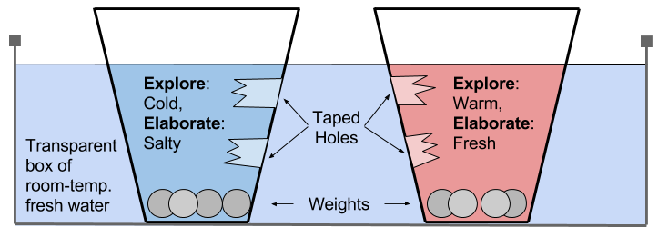
After creating the display, prepare the water pitchers for the Exploration and Elaboration activities. The following list describes the necessary pitchers:
- Exploration Red: Fill this pitcher with water warmed on a hotplate or in a microwave. Label this pitcher “Exploration” and dye the water red.
- Exploration Blue: This pitched will be filled with water and ice. Label this pitcher “Exploration” and dye the water blue.
- Elaboration Red: This pitcher will contain red-dyed room-temperature water. Label it “Elaboration”.
- Elaboration Blue: Create saltwater by adding table or sea salt to room-temperature water. Label this pitcher “Elaboration” and dye the water blue.
Finally, prepare the plastic cups by poking a hole below the water line and another near the bottom, and print the prediction maps.

Engage | Temperature Movement
Time: 15 minutes
Materials: display model (see Preparation)
Have the display model, created in the Preparation section, in front of your class when they enter the room.
Knowledge Activation: Display or draw the surface current map below and ask, “What happens when the surface currents reach the poles?”
Ask again, “What happens when the surface currents reach the poles?” And, “What temperature is the water when it leaves the equator? What happens to that temperature when the water reaches the poles?”

Explore | The Thermocline
Time: 30 minutes
Materials: paper, colored pencils, transparent plastic bins, prepared plastic cups, tape, small weights (i.e. marbles, rocks, coins), pitcher of Exploration Red and Exploration Blue (see Preparation)
To have your students explore temperature’s effect on water flow, use the following steps to complete part of the Exploring Our Fluid Earth activity.
- Break your class into pairs or teams of three and distribute paper, colored pencils, a plastic bin, two prepared plastic cups, and tape to each team.
- Instruct the teams to patch the plastic cup holes with tape, add weight to the bottom of the cups, and fill the bin with tap water.
- Go to each group; fill one plastic cup with Exploration Red (warmed red-dyed water) and the other with Exploration Blue (chilled blue-dyed water). Tell the groups that the red water will be warm and the blue water will be cold. Instruct the group to place the cups in their bin with the tape facing each other. Have the students sketch the model and draw their predictions as to where the water will move.
- Once step 5 is completed for every group, have all teams carefully remove the tape from the plastic cups and record their observations.

Explain | Upwelling and Downwelling
Time: 10 minutes
Materials: blackboard or whiteboard, chalk or dry-erase markers
Define the Thermocline and introduce the terms: upwelling and downwelling. Show or draw the following diagram

Elaborate | Salinity
Time: 30 minutes
Materials: water, tape, pitcher of Elaboration Red and Elaboration Blue (see Preparation)
Knowledge Activation: Ask the class, “Why is the ocean salty?” And, “Does all ocean water have the same salinity?”
Note: If your class plans on recycling the plastic cups from the Exploration section, be sure to dry them thoroughly so the fresh tape will stick.
- Have the teams or pairs fill their plastic bin with new water and replace the cups.
- Go to each group; fill one plastic cup with Elaboration Red (fresh water) and the other with Exploration Blue (salt water). Tell the groups that the blue water has high salinity and the red is fresh water. Instruct the group to place the cups in their bin with the tape facing each other. Have the students sketch the model and draw their predictions as to where the water will move.
- Once step 2 is completed for every group, have all teams carefully remove the tape from the plastic cups and record their observations.

Evaluate | The Global Conveyor Belt
Time: 20 minutes
Materials: printed Atlantic and Pacific prediction maps (see Appendix), red and blue colored pencils
Ask, “What happens to surface currents when they reach the poles?” Define Thermohaline circulation, or the Global Conveyor Belt.
Distribute the a prediction map, a red and a blue colored pencil to each student and ask them to draw the Global Conveyor Belt, the combination of surface and deep currents around the world. Have them draw the warm currents in red and cold in blue.
Ask your students to share their predictions. After a brief discussion, draw or display the following Thermohaline map on your board.
Knowledge Activation: Ask, “How do the sun and moon impact ocean mechanics?” Students should recall past lessons on tidal bulges and the Coriolis effect.

Empower | Glacial Melt
Time: 15 minutes
Context Setting for Action Plan: Ask your students, “Can the global conveyor belt change?” After a brief discussion, ask, “What would happen if the poles warmed?” Encourage your students to investigate this issue.

References
“Activity: Modeling Thermohaline Water Flow.” Exploring Our Fluid Earth. Curriculum Research & Development Group, University of Hawaii: 2017. <http://bit.ly/2q2BTTR>
“Currents Effects of Climate Change.” National Ocean Service Education. NOAA. <http://bit.ly/2dSyORu>

Middle School Unit 1, Lesson 4 | Sea Level Rise
  - 6E Lesson Plan and Teacher Prep

Instructor:
Grade/Class:

Overview
Driving Question: What causes sea level rise and how does this phenomenon impact ocean mechanics?
Abstract: Students activate their knowledge of ocean mechanics to evaluate the causes and consequences of sea level rise.
Lesson Objectives: TSWBAT (1) identify the primary factors contributing to sea level rise, (2) model eustatic sea level rise, (3) illustrate glacial isostatic adjustment, and (4) compare the impact of sea level rise on different regions.
Time: 120 minutes
Materials:
- Cold water  - Conical flasks  - Blue dye  - Two-hole corks  - Glass tubes  - Thermometers | - Rulers  - Lamps and outlets  - Transparent plastic bins  - Modeling clay  - Pushpins  - Bucket of ice

Ocean Literacy Principles: OL-1 The Earth has one big ocean with many features; OL-2 The ocean and life in the ocean shape the features of Earth.
NGSS Crosscutting Concepts: (1) Patterns; (4) Systems and system models; (5) Energy and matter
NGSS Practices: (1) Asking questions; (6) Constructing explanations; (7) Engaging in argument from evidence
NGSS Performance Expectation: MS-ESS3-2 Analyze and interpret data on natural hazards to forecast future catastrophic events and inform the development of technologies to mitigate their effects.

Preparation
Time: 20 minutes
Materials: transparent plastic bins, modeling clay, pushpins, bucket of ice, water, blue dye
The Explanation section implements a modified activity from Regan Alsup and Tim Watkins of the National Park Service Climate Change Response Program (see References). To create the glacial melt boxes for this activity, refer to the graphic below. Each group of students will be given two boxes: one with glaciers (ice on the clay) and another with icebergs (ice in the water).
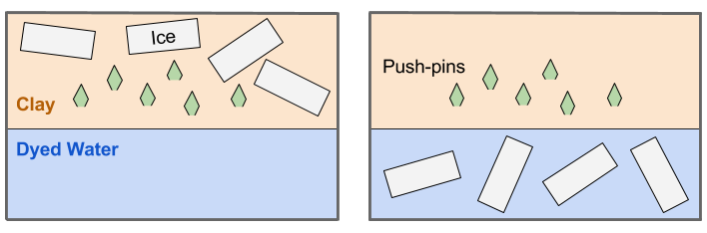

Engage | Melting Ice
Time: 15 minutes
Materials: Internet access and a projector
Knowledge Activation: Review the previous lessons, Modeling Weather and Thermohaline Circulation, and ask, “How does the ocean change? And how do these changes impact ocean mechanics?” Specifically refer to the slowing global conveyor belt and spreading ocean floor.
Ask your class to share what they know about sea level rise and, “What causes sea level rise?” Show one of the following videos on ice melt:
- National Geographic 2017 short film (Recommended): http://bit.ly/2qjS9zl
- National Geographic 2015 Glacier National Park video: http://bit.ly/2qk1vLv
- National Geographic 2015 short film: http://bit.ly/2rUoE8i
- World Bank 2012 Andes video: http://bit.ly/2rZ5vRS
Ask, “How much do you think melting ice contributes to sea level rise?”

Explore | Eustatic Sea Level Rise
Time: 30 minutes
Materials: cold water, blue dye, conical flasks, corks, scissors, two-hole cork/stoppers, glass tubes, thermometers, rulers, lamps, outlets
Ask your students, “As Earth’s atmosphere continues to warm, what happens to the ocean?” After fielding answers, follow these steps to begin the thermal expansion activity:
Follow these steps with your students to create the thermal expansion models for a modified Windows to the Universe activity by Lisa Gardiner (see References):
- Break your class into pairs or teams of three and distribute the materials.
- Instruct students to fill the conical flasks with cold water and add blue dye.
- Insert the glass tube and thermometer into the two-hole cork.
- Insert the cork into the conical flask as shown in the graphic on the right.
- Instruct students to record the water’s level and temperature
- Have them place their thermal expansion model under a lamp, with the light shining on the water.
Knowledge Activation: While teams wait for their thermal expansion model to warm, discuss the gradual warming of Earth’s atmosphere, the natural and anthropogenic causes, potential solutions and adaptations. After the discussion, have the groups return to their thermal expansion models.
- Instruct students to record the water’s level and temperature.
- Ask each group to share their observations. Hold a brief discussion in regards to this experiment’s relationship to eustatic sea level rise.

Explain | Glacial Melt
Time: 30 minutes
Materials: glacial melt boxes (see Preparation), lamps, outlets
Knowledge Activation: Ask your students, “As Earth’s atmosphere continues to warm, what happens to the ice?” Then ask students, “Does the sea level change when ice melts?” Then ask, “Does the location of ice, either on land or in the ocean, make a difference?” After a brief discussion, follow these instructions to begin glacial melt activity:
- Distribute two glacial melt boxes (see Preparation) to each group.
- Instruct each team to label both boxes, one as the Iceberg Box and the second as the Glacier Box.
- Have one member of each team retrieve eight to twelve cubes of ice for their group. Instruct the groups to put half of the ice in the water of the Iceberg Box and the other half on the clay land in Glacier Box.
- Instruct the teams to record the water level in the Iceberg and Glacier boxes.
- Instruct them to place the boxes under the lamps.
While waiting for the ice to melt, ask, “How much of Earth’s water is contained in glaciers and ice caps?” After fielding answers, draw or display the following graphic and discuss its implications.
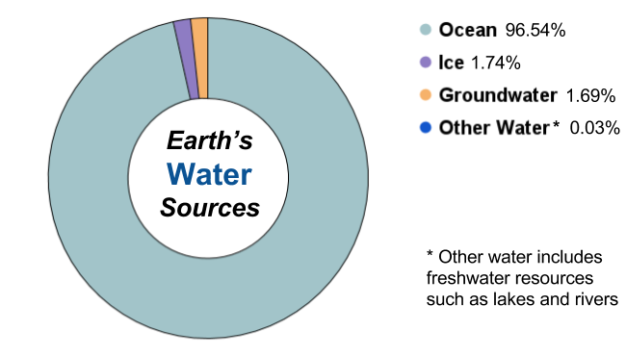
After discuss the chart, return to the glacial melt boxes. Once all ice has melted follow these instructions to complete the activity:
- Instruct students to record the water levels in the Glacier and Iceberg boxes.
- Ask each group to share their observations. Hold a brief discussion in regards to this experiment’s relationship to eustatic sea level rise

Elaborate | Glacial Isostatic Adjustment
Time: 15 minutes
Materials: whiteboard or blackboard, dry-erase-markers or chalk, globe
Ask your students, “Have there always been glaciers on Earth’s surface?” Then ask, “What happens to continental crust when a glacier forms?” After fielding answers, review subsidence by drawing the graphic below.
Now ask, “What happens to the continental crust when glaciers melt?” Explain the process of uplift by using the following graphic.
Knowledge Activation: Ask, “If the continental crust under melting glaciers undergoes uplift, what happens to other areas of the continental shelf?” Explain glacial isostatic adjustment. To help students visualize this phenomenon, refer to the tectonic plate map below.

Evaluate | Changing Ocean Mechanics
Time: 15 minutes
Knowledge Activation: Ask, “How will the melting of ice impact thermohaline circulation?” To help students visualize this phenomenon, refer to the global conveyor belt map from the lesson on Thermohaline Circulation. After discussing the relationship between water temperature and deep ocean currents, ask, “How does the global conveyor belt alter eustatic sea level rise?”
To help answer this question, you can show your class the following Kurzesagt video: http://bit.ly/2vnlhsz. This video gives an overview of thermohaline circulation and explains the possibility of thermohaline slowdown. Ask, “How could the possible slowdown of the global conveyor system impact regional sea level rise?”

Empower | Regional Sea Level Rise
Time: 15 minutes
Context Setting for Action Plan: Ask, “What are the consequences of sea level rise for coastal communities?” And then, “What other phenomena could worsen the effects of sea level rise?” Discuss storm surge, shoreline erosion, and regional subsidence with your students. The following two resources may help with engagement.
- National Geographic “Rising Seas” images: http://on.natgeo.com/2khiJGv
- National Geographic “Storm Surge” video: http://bit.ly/2ovUTNe
Have pairs or teams identify different communities subjected to regional sea level rise and have them compare the factors contributing to this phenomenon.

References
Alsup, Regan and Tim Watkins. “Why Melting Glaciers Matter to the Coasts.” National Park Service Climate Change Response Program: 2014. <http://bit.ly/2vDnYWa>
Folger, Tim and George Steinmetz. “Rising Seas.” National Geographic: 2013. <http://on.natgeo.com/2khiJGv>
Gardiner, Lisa. “Thermal Expansion and Sea Level Rise.” Windows to the Universe: 2007. <http://bit.ly/2gLq8QK>
“He’s Watching This Glacier Melt Before His Eyes.” Short Film Showcase. National Geographic: 2017. <http://bit.ly/2qjS9zl>
“Melting glaciers: The Slow Disaster in the Andes.” World Bank: 2012. <http://bit.ly/2rZ5vRS>
“Photo Evidence: Glacier National Park Is Melting Away.” National Geographic: 2015. <http://bit.ly/2qk1vLv>
“Sea Level Glossary.” Sea Level Change from Space. NASA. <https://sealevel.nasa.gov/glossary>
“See the Extreme Ice Changes Near the Antarctic Peninsula.” Short Film Showcase. National Geographic: 2015. <http://bit.ly/2rUoE8i>
“Storm Surge.” National Geographic: 2007. <http://bit.ly/2ovUTNe>
“The Gulf Stream Explained.” Kurzesagt: 2013. <http://bit.ly/2vnlhsz>

