High School Unit 1 | Ocean Mechanics
  - Unit Overview

Unit Goals
Big Idea: What are the mechanics behind ocean processes?
Abstract: In this Earth Science unit, students explore the atmospheric, celestial, geologic, and hydrologic phenomena responsible for ocean mechanics and the impact of these mechanics on other Earth processes. Students begin with lessons on Atmospheric Circulation and the Hydrologic Cycle, reviewing the atmospheric and meteorological mechanics behind ocean physics. Then, they explore changes in ocean mechanics. In the Seafloor Spreading lesson, they explain this change using geological processes and, in the Sea Level Rise lesson, they evaluate eustatic and regional changes in sea level and their implications on other oceanic processes.
Ocean Literacy Principles:
- The Earth has one big ocean with many features.
- The ocean and life in the ocean shape the features of Earth.
- The ocean is a major influence on weather and climate.
NGSS Crosscutting Concepts: (1) Patterns; (4) Systems and system models; (5) Energy and matter
NGSS Practices: (1) Asking questions; (6) Constructing explanations; (7) Engaging in argument from evidence

Contents
Item  Unit Overview  Explanation and Glossary  Lesson 01 | Atmospheric Circulation  Lesson 02 | The Hydrologic Cycle  Lesson 03 | Seafloor Spreading  Lesson 04 | Sea Level Rise  Student Pages | Pages  1  2 through 11  12 through 16  17 through 22  23 through 27  28 through 33  34 through 36

High School Unit 1 | Ocean Mechanics
  - Explanation and Glossary

Ocean Mechanics Explanation
In this Earth Science unit, students explore the atmospheric, celestial, geologic, and hydrologic phenomena responsible for ocean mechanics and the impact of these mechanics on other Earth processes.
High school students begin this unit by engaging the atmosphere’s impact on ocean mechanics. Some students may know the doldrums made infamous by sailors in popular culture. Doldrums fall along the Intertropical Convergence Zone, the area where trade winds converge. These perpetual winds move toward the equator from the northeast in the northern hemisphere and the southeast in the southern hemisphere. Air pressure and temperature differences may fuel this movement, but the deflection of the winds occurs due to Earth’s rotation. The Coriolis Effect, displayed in Figure 1.01, causes motion north of the equator to bend eastward and motion south of the equator to bend westward. At the same time, air is continually rising and falling, forming circulation cells. Air near the equator warms, moves toward the equator, converges, rises, cools, and begins to fall again. The circulation cells converging at the equator are called Hadley Cells, depicted in Figure 1.02, and responsible for the creation of subtropical deserts, such as the Sahara. These deserts are created by the divergence of colder, denser air between the Hadley Cells and the adjacent Ferrell Cells.
These atmospheric processes impact the movement wind creating waves and surface currents, but also impact the movement of water through the hydrologic cycle. This cycle, commonly referred to as the water cycle, begins with the evaporation of ocean water at Earth’s equator. When water droplets collide, grow, and drop from a cloud, precipitation occurs. These processes are depicted in Figure 1.03. Rainwater flows upon Earth’s surface, causing erosion on its way to standing water. Water reaching the ocean may form brackish water estuaries where freshwater meets and mixes with seawater. In regards to salinity, freshwater has 0 to 0.5 parts per thousand (ppt); brackish water has 0.5 to 30 ppt; and seawater has 30 to 50 ppt. Water with a higher salinity is denser and plays an essential role in thermohaline circulation, the worldwide movement of ocean water due to differences in temperature and salinity. The warmer surface water moves from the equator to the poles where it cools, becomes denser, and sinks. This process is called downwelling and displayed in Figure 1.04. Cold water near the poles has higher salinity due to the salt remaining after some water freezes. The colder, denser water then moves toward the equator where it undergoes upwelling: warming, losing its salinity, and rising. Worldwide ocean water circulation, depicted in Figure 1.05, is commonly known as the global conveyor belt and changes over time.
The ocean is under a constant state of change. Its floor, made of dense oceanic crust, floats atop Earth’s mantle below the less-dense continental crust. Over three hundred million years ago, Earth’s continental crust was consolidated into a supercontinent called Pangaea. Over time, the continent split and the Atlantic seafloor began spreading. Seafloor spreading continues to this day. As older crust becomes denser and undergoes subduction, new oceanic crust forms along mid-ocean ridges shown in Figure 1.06. This global movement of crust, plate tectonics, gradually changes the ocean and is depicted in Figure 1.07.
Sea level also changes over time. As Earth’s average temperature continues to rise, glacial ice will melt and water molecules will undergo thermal expansion. Both factors contribute to eustatic sea level rise, an increase of the global mean sea level. Sea level rise fluctuates at the local level as well. Glacial isostatic adjustment is a primary factor contributing to regional sea level rise. Also know as post-glacial rebound and depicted in Figure 1.08, this phenomenon occurs when continental plates readjust to pre-glacial heights after glacial ice melts. This process affects regions disproportionately. As certain areas of continental crust uplift, other areas will subside. Additional subsidence, caused by ground resource withdrawal, can increase the impact of sea level rise.
To set the context for student-led action planning, this unit links ocean mechanics and society. For coastal communities, sea level rise may directly impact local livelihoods and tracking this change could be of interest to your students. These phenomena impact storm surges damaging property and posing a danger to affected communities. On a broader scale, students may be interested in the impact of glacial melt on thermohaline circulation and the impact of thermohaline slowdown on other ocean processes. Other processes, such as shoreline erosion and earthquakes, may directly impact your community. Encourage your students to use scientific methods to investigate any issue.

Appendix
Figure 1.01 | The Coriolis Effect
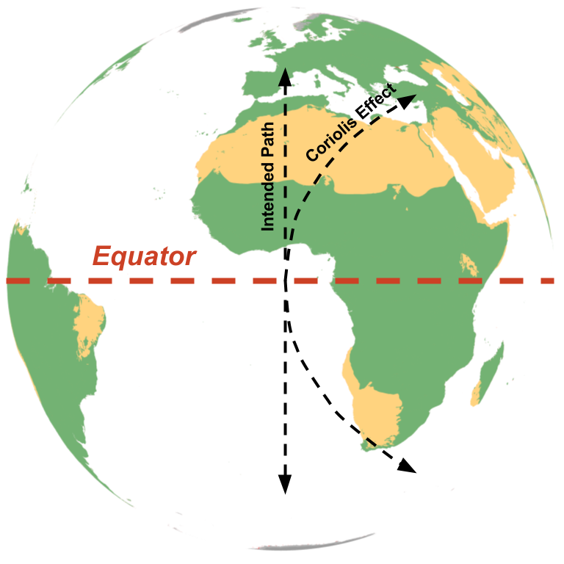
Figure 1.02 | Hadley Cells
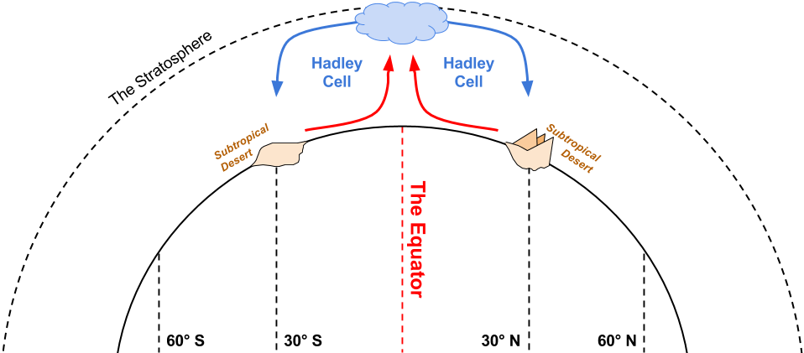

Figure 1.03 | Evaporation & Precipitation
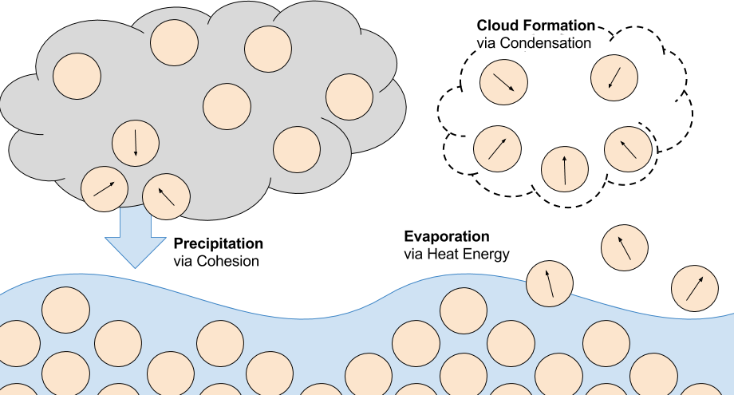
Figure 1.04 | Upwelling
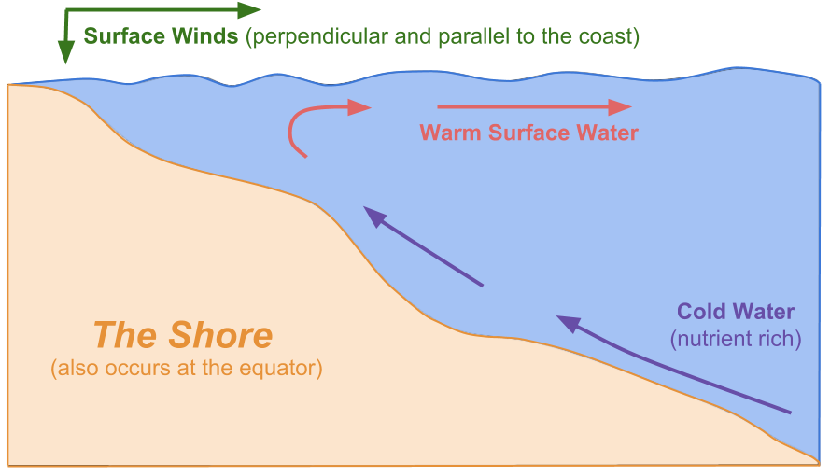

Figure 1.05 | Thermohaline Circulation
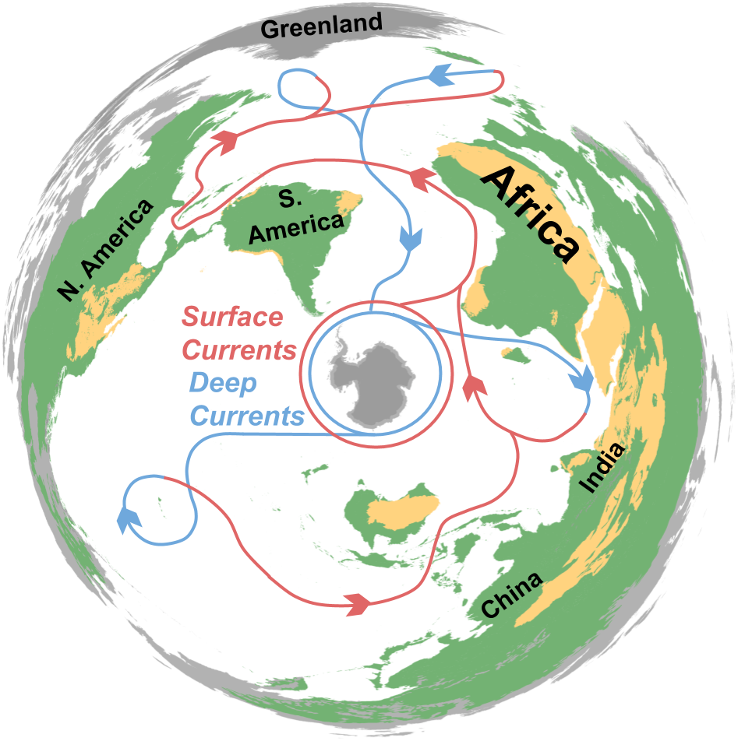
Figure 1.06 | The Mid-ocean Ridge

Figure 1.07 | Tectonic Plate Subduction
Figure 1.08 | Glacial Isostatic Adjustment

Glossary
Adhesion | The property of water that causes it to be attracted to other substances. Also see cohesion.
Alluvial Fans | A fanning area of sediment deposited by a stream.
Asthenosphere | The relatively soft mantle below the lithosphere.
Atmospheric Circulation | The worldwide movement of air largely due to celestial mechanics, influencing ocean current circulation.
Atmospheric Pressure | Weight of the atmosphere on Earth’s surface modified by temperature variation, among other factors.
Axis of Rotation | Earth’s circular movement occurs around an imaginary line called its axis of rotation. Earth completes its eastward rotation once every 24 hours.
Brackish Water | Water with a salinity of 0.5 to 30 parts per thousand, found where the ocean meets freshwater resources.
Buoyancy | Upward force of a fluid opposing the weight of an immersed object.
Celestial Mechanics | The processes responsible for the movement of celestial objects such as Earth, the sun, and moon.
Centrifugal Force | Force directed away from an object spinning around an axis of rotation.
Cohesion | The property of water that causes it to be attracted to water. Also see adhesion.
Collision | The convergence of two pieces of buoyant lithosphere. Also see rifting.
Continental Crust | Less-dense lithospheric crust floating on top of the mantle. Also see oceanic crust.
Convection | The movement of molecules through gases and liquids, such as the movement of thermal energy through the atmosphere, ocean, and mantle.
Convergence Zone | Area where moving surface air meets and rises. Also see divergence zone.
Coriolis Effect | Deflection of a motion across Earth’s surface due to the planet’s rotation. Motion north of the equator bends eastward, while motion south of the equator bends westward.
Currents | The continuous movement of water due to waves, wind, temperature differences, density differences, Earth’s rotation, and tidal changes.
Deserts | Barren landscapes with little precipitation.
Doldrums | Areas of the ocean with an absence of trade winds due to the Intertropical Convergence Zone.
Downwelling | The movement of surface water downwards due to temperature or density changes, or other processes along shorelines. Also see upwelling.
Divergence Zone | Area where air sinks and separates into air flows moving in the opposite direction. Also see convergence zone.
Earth-sun-moon System | The movement of Earth, its moon, and the sun in relation to each other and their gravitational forces.
Erosion | Removal of sediment by water, wind, or other natural phenomena. In the case of this unit, students explore shoreline erosion by waves and tides.
Equator | Imaginary circle around Earth, perpendicular to the planet’s axis of rotation.
Eustatic Sea Level Rise | Increase of the global mean sea level.
Evaporation | Process in which liquid turns into vapor. Also see precipitation.
Glacial Isostatic Adjustment | Continental plates readjust to pre-glacial heights after glacial ice melts.
Glacier | A perennial body of ice slowly flowing across land.
Global Conveyor Belt | See thermohaline circulation.
Gyres | Systems of continuous surface winds and currents in the open ocean.
Hadley Cells | Convection cells near the equator responsible for the creation of subtropical deserts, such as the Sahara.
Hurricane | A rotating storm system with winds at least 119 km/h (64 knots) formed in tropical climates and strengthened over warm water.
Hydrologic Cycle | The movement of water between the ocean, atmosphere, biosphere, Earth’s surface, and groundwater reservoirs.
Iceberg | Large block of ice floating in the ocean.
Intertropical Convergence Zone | The equatorial area where warm air converges and rises. Also known as the doldrums.
Isobar | A cartographic line used to show where air pressure is the same.
Lithosphere | The outermost layer of Earth, made of the crust and part of the mantle.
Mantle | Layer of rock between Earth’s crust and core.
Mid-ocean Ridge | Belt of submarine mountains along divergent plate boundaries. This is where new oceanic crust forms during seafloor spreading.
Neap Tide | Significantly smaller tides occurring when the sun and moon form a 90° angle. Also see spring tides.
Ocean Mechanics | The atmospheric, hydrologic, and geologic processes contributing to ocean physics such as winds, waves, and currents.
Oceanic Crust | Dense lithospheric crust floating on top of the mantle. Also see continental crust.
Pangaea | The supercontinent existing three hundred million years ago.
Plate Tectonics | Theory suggesting Earth’s lithosphere is made of large, constantly moving pieces.
Poles | The two point at opposite ends of Earth’s axis of rotation. Earth’s poles, covered in ice caps, receive less exposure to the sun than the rest of the planet’s surface.
Precipitation | When water droplets collide, grow, and drop from a cloud Also see evaporation.
Rifting | The divergence of two pieces of buoyant lithosphere. Also see collision.
Salinity | Percentage of salt dissolved in a body of water. Freshwater has 0 to 0.5 parts per thousand (ppt); brackish water has 0.5 to 30 ppt; and seawater has 30 to 50 ppt. Water with a higher salinity is denser and plays an essential role in thermohaline circulation.
Sea Level Rise | The increase in the sea level’s height relative to its average height at given point in time. This rise can be temporary or long term, and regional or eustatic.
Seafloor Spreading | Gradual expansion of ocean basins due to the formation of new oceanic crust at mid-ocean ridges and the downwelling of old crust at subduction zones.
Sediment | Natural material broken down by natural processes, such as weathering and erosion, and transported by water or wind.
Shoreline | Land geologically modified over time by the body of water at its edge.
Spring Tide | Significantly higher tides occurring when the sun and moon are on the same plane. Also see neap tides.
Storm Surge | Temporary sea level rise due to atmospheric changes.
Subduction | Process causing an ocean plate to sink beneath an adjacent plate into the asthenosphere.
Subsidence | The sinking of Earth’s surface due to processes such as ground resource withdrawal and glacial isostatic adjustment.
Surface Currents | The movement of water up to 10 meters below the ocean surface. The maximum velocity of these currents occurs at the surface due to the friction of wind.
Thermocline | The dramatic decrease in temperature between ocean layers.
Thermohaline Circulation | The worldwide movement of ocean water due to differences in temperature and salinity, commonly referred to as the global conveyor belt.
Thermohaline Slowdown | The potential slowing of thermohaline circulation due to glacial melt. As polar ice melts, salinity drops, weakening the movement of water around the world.
Tidal Bulge | Temporary worldwide sea level rise due to the gravitational pull of the moon and sun, and the centrifugal force of Earth’s rotation.
Trade Winds | Perpetual winds moving toward the equator from the northeast in the northern hemisphere and the southeast in the southern hemisphere. Air pressure and temperature differences, along with Earth’s rotation, create this movement.
Upwelling | The movement of surface water upwards due to temperature or density changes, or other processes along shorelines. Also see downwelling.
Water Cycle | See hydrologic cycle.
Waves | The movement of energy through water.

High School Unit 1, Lesson 1 | Atmospheric Circulation
  - 6E Lesson Plan and Teacher Prep

Instructor:
Grade/Class:

Overview
Driving Question: What forces affect atmospheric movement and how does this movement impact ocean mechanics?
Abstract: In this lesson, students explore major atmospheric processes, their relationships, and how they impact ocean mechanics.
Lesson Objectives: TSWBAT (1) draw and model the forces causing temperature circulation in Earth’s atmosphere, (2) use the terms Coriolis Effect, Hadley Cells, convergence and divergence to describe atmospheric circulation, and (3) identify the impacts of atmospheric processes on ocean surface mechanics.
Time: 90 minutes
Materials:
- Water  - Microwave or hotplate  - Ice or refrigerator  - Red and blue dye  - Transparent plastic bins with a recommended length between 38 and 50 cm (15 and 20 inches) | - Transparent plastic cups or recycled water bottles  - Scissors and tape  - Reusable towels  - Four pitchers  - Paper and colored pencils  - Internet access and projector

Ocean Literacy Principles: OLP-2 The ocean and life in the ocean shape the features of Earth; OLP-3 The ocean is a major influence on weather and climate.
NGSS Crosscutting Concepts: (1) Patterns; (4) Systems and system models; (5) Energy and matter
NGSS Practices: (1) Asking questions; (6) Constructing explanations; (7) Engaging in argument from evidence
NGSS Performance Expectation: HS-ESS2-4 Use a model to describe how variations in the flow of energy into and out of Earth’s systems result in changes in climate.

Preparation
Time: 25 minutes
Materials: water, a transparent plastic bin, transparent plastic cups, scissors, tape, small weights (i.e. marbles, rocks, coins), red and blue dye, hotplate or microwave, two pitchers
To prepare for this lesson, three items must be completed: (1) create the display model, (2) fill the water pitchers, and (3) prepare plastic cups.
Create the display model for the Elaboration activity based on the Exploring Our Fluid Earth activity from the University of Hawaii (see References). Use the materials list above and the following modified diagram to create the display.
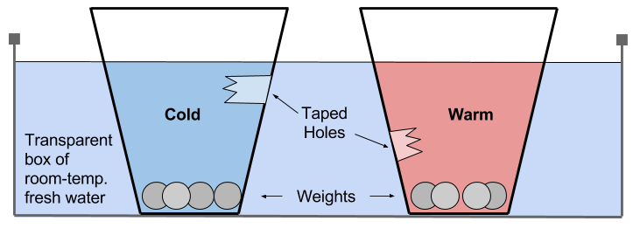
After creating the display, use the following descriptions to prepare the water pitchers for the Elaboration activity.
- Red: Fill this pitcher with water warmed on a hotplate or in a microwave and dye the water red.
- Blue: This pitched will be filled with water and ice and dye the water blue.
Finally, prepare the plastic cups by poking a hole below the water line for one set of cups (the Blue set) and one near the bottom for the second set (the Red set).

Engage | Intertropical Convergence Zone
Time: 5 minutes
Materials: Internet connection and a projector
Knowledge Activation: “What creates ocean surface currents and winds?” Then show a map featuring Earth’s equator, define the doldrums, and ask, “What creates the doldrums, the area of the ocean with an absence of trade winds?”
Use the following link to show a video of a sailboat trapped in the doldrums: http://bit.ly/2pX0N6Q.

Explore | The Spinning Sphere
Time: 20 minutes
Materials: paper, colored pencils, several pieces of poster board, colored markers, whiteboard or blackboard, dry-erase markers or chalk
Ask, “What are the mechanics behind trade winds? And how does Earth’s rotation affect movement on its surface?”
Students model the Coriolis Effect using a modified activity, originally developed by Jerry D. Roth for NOAA and NSTA (see References). This activity is broken into the following steps:
- Distribute pieces of paper and colored pencils and ask your students to predict how a straight line will be drawn on a moving piece of paper. To clarify your question, roll up a piece of poster board and turn it clockwise to simulate the movement for your class.
- Now pick two students to help with the activity.
- Spin a the poster board clockwise and have the first student practice drawing a straight line down with the back of a marker. After they’ve practiced, have them draw a straight line down while you turn the paper. If they make a mistake, try again.
- Ask your class to explain what happened. And then ask, “What will happen if I spin the paper the other way?”
- Have the second student repeat Step 3 with a different colored marker on fresh poster board, while you spin the paper counter-clockwise.

Explain | The Coriolis Effect
Time: 10 minutes
Materials: whiteboard or blackboard, dry-erase markers or chalk
Ask your class what happened. After discussing the phenomena, draw a diagram of the Coriolis Effect such as the one on the following page.

Elaborate | Hadley Cells
Time: 30 minutes
Materials: paper, colored pencils, transparent plastic bins, prepared plastic cups, tape, small weights (i.e. marbles, rocks, coins), pitcher of Red and Blue (see Preparation)
Now ask, “What role does temperature play in atmospheric circulation?”
To have your students explore temperature’s effect, use the following steps to complete part of the Exploring Our Fluid Earth activity.
- Break your class into pairs or teams of three and distribute paper, colored pencils, a plastic bin, two prepared plastic cups, and tape to each team.
- Instruct the teams to patch the plastic cup holes with tape, add weight to the bottom of the cups, and fill the bin with tap water.
- Go to each group; fill one plastic cup with Exploration Red (warmed red-dyed water) and the other with Exploration Blue (chilled blue-dyed water). Instruct the group to place the cups in their bin with the tape facing each other. Have the students sketch the model and draw their predictions as to where the water will move.
Once step 5 is completed for every group, have all teams carefully remove the tape from the plastic cups and record their observations.

Evaluate | Convergence v. Divergence
Time: 15 minutes
Materials: paper, colored pencils
Ask your class, “What does this look like in the atmosphere?” Have your students sketch their predictions, then draw or display the diagram below.
Now ask, “What happens on the other ends of the Hadley Cells? Does all of the cool air warm and move to the equator?”

Empower | Atmospheric Patterns
Time: 10 minutes
Context Setting for Action Plan: Ask your class, “So what? How does atmospheric circulation impact ocean mechanics?” After a brief discussion, ask, “How can we use our knowledge of Hadley Cells and the Coriolis Effect to mitigate the effects of natural disasters?”

References
“Activity: Modeling Thermohaline Water Flow.” Exploring Our Fluid Earth. Curriculum Research & Development Group, University of Hawaii: 2017. <http://bit.ly/2q2BTTR>
Roth, Jerry D. “Twisting the Air Away – The Coriolis Effect.” NOAA Education.
“Trapped in the doldrums.” Hope – Sailing the world: 2015. <http://bit.ly/2pX0N6Q>

High School Unit 1, Lesson 2 | The Hydrologic Cycle
  - 6E Lesson Plan and Teacher Prep

Instructor:
Grade/Class:

Overview
Driving Question: What role does temperature play in the movement of water during the hydrologic cycle?
Abstract: Students explore thermohaline circulation and the ocean’s role in the hydrologic cycle.
Lesson Objectives: TSWBAT (1) explain the movement of water using the terms cohesion, adhesion, sedimentation, evaporation and precipitation, (2) model the effects of temperature and density on water movement, and (3) draw the movement of water through the hydrologic cycle.
Time: 90 minutes
Materials:
- Water  - Microwave or hotplate  - Ice or refrigerator  - Red and blue dye  - Transparent plastic bins with a recommended length between 38 and 50 cm (15 and 20 inches) | - Transparent plastic cups or recycled water bottles  - Scissors and tape  - Reusable towels  - Four pitchers  - Paper and colored pencils  - Internet access and projector

Ocean Literacy Principles: OLP-1 The Earth has one big ocean with many features; OLP-3 The ocean is a major influence on weather and climate.
NGSS Crosscutting Concepts: (1) Patterns; (4) Systems and system models; (5) Energy and matter
NGSS Practices: (1) Asking questions; (6) Constructing explanations; (7) Engaging in argument from evidence
NGSS Performance Expectation: HS-ESS2-5 Plan and conduct an investigation of the properties of water and its effects on Earth materials and surface processes.

Preparation
Time: 25 minutes
Materials: saltwater and fresh water, a transparent plastic bin, transparent plastic cups, scissors, tape, small weights (i.e. marbles, rocks, coins), red and blue dye, two pitchers, printer
To prepare for this lesson, three items must be completed: (1) create the display model, (2) fill the water pitchers, (3) prepare plastic cups, and (4) print the prediction maps (see Appendix).
Create the display model for the Elaboration activity based on the Exploring Our Fluid Earth activity from the University of Hawaii (see References). Use the materials list above and the following modified diagram to create the display.
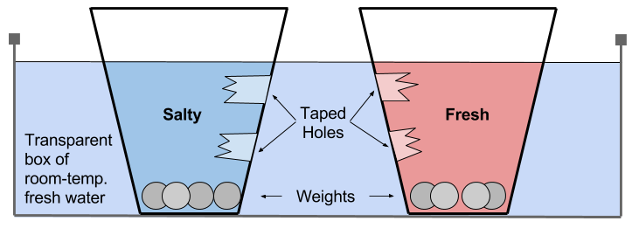
After creating the display, use the following descriptions to prepare the water pitchers for the Elaboration activity.
- Red: Fill this pitcher with red-dyed fresh water.
- Blue: This pitched will be filled with blue-dyed saltwater.
Finally, prepare the plastic cups by poking a hole below the water line and another near the bottom, and print the prediction maps.

Engage | Alluvial Fans & Brackish Water
Time: 10 minutes
Materials: transparent plastic bin, soil, cup of water
Knowledge Activation: In front of your class, put soil in one corner of a plastic bin and pour water onto the pile so that it carries soil into the uncovered part of the bin. Ask your class, “What happens when rivers meet the ocean?”
Review the terms cohesion and adhesion in regards water properties and sedimentation.

Explore | The Water Cycle
Time: 20 minutes
Materials: paper, colored pencils
Ask, “How does water move from the ocean into streams?”
Knowledge Activation: Have students draw a diagram of the hydrologic cycle including the following elements.
- The ocean  - Evaporation  - Clouds  - Precipitation | - Surface water (i.e. lakes, streams)  - Groundwater  - Ice caps

Explain | Evaporation & Precipitation
Time: 10 minutes
Materials: whiteboard or blackboard, dry-erase markers or chalk
Instruct the students to explain their diagrams then ask them to explain the processes of evaporation and precipitation as they relate to the hydrologic cycle. Draw or display the following graphic and ask students to add these terms to their diagrams.

Elaborate | Thermohaline Circulation
Time: 30 minutes
Materials: paper, colored pencils, transparent plastic bins, prepared plastic cups, tape, small weights (i.e. marbles, rocks, coins), pitcher of Red and Blue (see Preparation)
Ask, “How much of Earth’s water is in the ocean?” After fielding answers, draw or display the following pie chart.
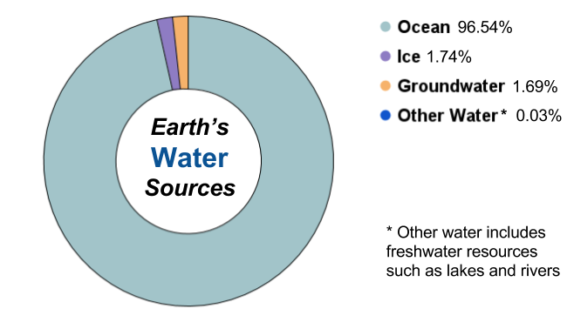
Knowledge Activation: Ask your class, “We know how water moves between Earth’s spheres, but how does it move in the ocean itself?” After fielding some answers, ask, “What forces create ocean currents?” Recall the previous lesson’s activity on temperature movement in water and ask how salinity will affect this movement.
To have your students explore salinity’s effect on water flow, use the following steps to complete part of the Exploring Our Fluid Earth activity.
- Break your class into pairs or teams of three and distribute paper, colored pencils, a plastic bin, two prepared plastic cups, and tape to each team.
- Instruct the teams to patch the plastic cup holes with tape, add weight to the bottom of the cups, and fill the bin with tap water.
- Go to each group; fill one plastic cup with Exploration Red (red-dyed fresh water) and the other with Exploration Blue (blue-dyed saltwater). Instruct the group to place the cups in their bin with the tape facing each other. Have the students sketch the model and draw their predictions as to where the water will move.
Once step 5 is completed for every group, have all teams carefully remove the tape from the plastic cups and record their observations.

Evaluate | The Global Conveyor Belt
Time: 10 minutes
Materials: whiteboard or blackboard, dry-erase markers or chalk
Ask, “Is salinity higher in warm or cold water?” Then, “Where in the ocean do we find the saltiest water?”
Draw or display the following map so students can evaluate their understanding of Thermohaline circulation.
Knowledge Activation: Ask, “How does this map change your understanding of the hydrologic cycle?” Then ask, “What does thermohaline circulation tell us about the properties of water?”

Empower | A Changing Cycle
Time: 10 minutes
Context Setting for Action Plan: Ask your students, “Can the global conveyor belt change?” After a brief discussion, ask, “What would happen if the poles warmed?” Encourage your students to investigate this issue.

References
“Activity: Modeling Thermohaline Water Flow.” Exploring Our Fluid Earth. Curriculum Research & Development Group, University of Hawaii: 2017. <http://bit.ly/2q2BTTR>
“Currents Effects of Climate Change.” National Ocean Service Education. NOAA. <http://bit.ly/2dSyORu>

High School Unit 1, Lesson 3 | Seafloor Spreading
  - 6E Lesson Plan and Teacher Prep

Instructor:
Grade/Class:

Overview
Driving Question: How does the ocean floor change over time?
Abstract: Students explore how the ocean changes through seafloor spreading and the geologic processes responsible for this phenomenon.
Lesson Objectives: TSWBAT (1) explain the process of convection as it relates to sea floor spreading, (2) illustrate plate tectonics and the process of subduction, and (3) demonstrate an understanding of the geological mechanics behind seafloor spreading.
Time: 120 minutes
Materials:
- Colored modeling clay  - Beaker  - Hot Plate  - Water | - Red dye  - Scissors  - Paper and pencils  - Internet access and a projector
Student Pages: Atlantic and Pacific prediction maps, paper subduction cut-outs
Ocean Literacy Principles: OLP-1 The Earth has one big ocean with many features; OLP-2 The ocean and life in the ocean shape the features of Earth.
NGSS Crosscutting Concepts: (1) Patterns; (4) Systems and system models; (5) Energy and matter
NGSS Practices: (1) Asking questions; (6) Constructing explanations; (7) Engaging in argument from evidence
NGSS Performance Expectation: HS-ESS1-5 Evaluate evidence of the past and current movements of continental and oceanic crust and the theory of plate tectonics to explain the ages of crustal rocks.

Preparation
Time: 30 minutes
Materials: colored clay, paper subduction cut-outs (see Student Pages), scissors
To prepare for this lesson follow the instructions below to create (1) a clay model of the Mid-ocean ridge and (2) a series of paper subduction models.
Use the colored clay to model the mid-ocean ridge. Be sure to create the components included in the following diagram. The recommended height of the model is 12 cm and the recommended width is 15 cm. The model will be passed around your class in the Exploration section.
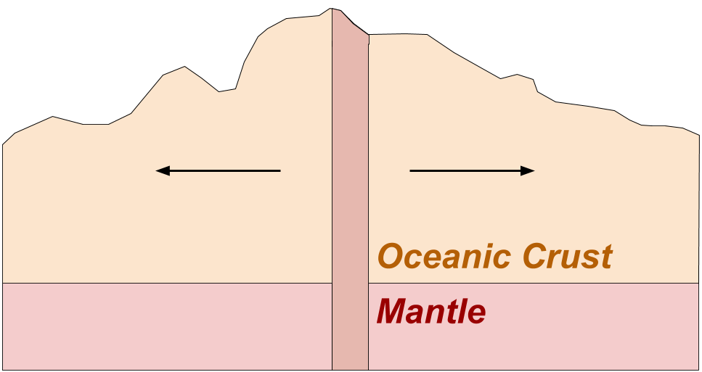
For this lesson, you will also be creating paper subduction models by cutting the paper subduction cutouts included in the Student Pages. This activity is a modified version of the “Sea Floor Spreading Made Easy” lesson by Christine McLelland and Ellen Metzger (see References).

Engage | Pangaea
Time: 15 minutes
Knowledge Activation: Ask you students, “How does the ocean impact other Earth systems? How does it interact with the hydrosphere and atmosphere?” Have the class draw upon the previous two lessons, Atmospheric Circulation and The Hydrologic Cycle.
After the brief discussion, ask, “Does the ocean change?” After fielding answers, use display a map of Pangaea. Ask, “How did we discover Pangaea and how does Earth’s surface change?”

Explore | Mid-ocean Ridge
Time: 30 minutes
Materials: Internet access and a projector, mid-ocean ridge clay model (see Preparation), paper and colored pencils, colored clay
Introduce your students to the mid-ocean ridge by displaying the following map or a bathymetric chart of the Atlantic.
Pass around the mid-ocean ridge model you prepared and ask, “What creates the mid-ocean ridge? Why does this part of the ocean floor have a significantly higher elevation? And what do the colors represent?” After fielding answers, display or draw a diagram of Earth’s internal structure.
Use the following steps to have your class model volcanic activity at the mid-ocean ridge:
- Break your class into pairs or groups of three and distribute the colored pencils and paper.
- Instruct the groups to sketch what Earth’s internal structure looks like below the mid-ocean ridge. They must include the (1) upper/crustal lithosphere, (2) lithospheric mantle, (3) asthenosphere, and (4) mid-ocean ridge.
- Once a group has completed their diagram, distribute the colored clay and instruct them to model their prediction.
- Groups share their models with the class upon completion.

Explain | Convection
Time: 20 minutes
Materials: Internet access and a projector, water, beaker, hot plate, red dye, eyedropper
Knowledge Activation: Ask the class to explain the mid-ocean ridge using the term, convection. Use the following steps to demonstrate convection.
- Place a beaker filled with water on a hot plate set to low heat. Note: Do not turn the hot plate high enough to cause boiling.
- Fill the eyedropper with red dye.
- Squeeze the red dye in the bottom-center of the beaker. The heat should cause the red water to rise and then fall again via convection. Repeat steps 1 through 3 if the desired effect is not achieved.
- Ask your class, “What’s happening here?”
Show your class NOAA’s first recording of volcanic activity on the sea floor by using one of the following links.
- NOAA: http://oceantoday.noaa.gov/deepoceanvolcanoes/
- Discovery: http://bit.ly/2rQO4E7
- National Geographic: http://bit.ly/2qWf6d2

Elaborate | Subduction
Time: 15 minutes
Materials: paper subduction models (see Preparation)
Ask, “While magma continually creates new seafloor, does all old seafloor remain in place?” After fielding answers, distribute the paper subduction models to the groups. Ask, “What happens when the seafloor spreads?”
Distribute the subduction models and instruct your students to follow the directions on the paper.

Evaluate | Seafloor Spreading
Time: 20 minutes
Materials: Atlantic and Pacific prediction maps (see Student Pages), projector
Distribute prediction maps and display the map below. Instruct your students to predict the locations of volcanoes and where earthquakes will occur. Display a map of tectonic plates, such as the one below, and define subduction zones.
Knowledge Activation: Ask students to identify the mid-ocean ridge in the tectonic plates map above.

Empower | Earthquake Tracking
Time: 20 minutes
Materials: Internet access and a projector
Context Setting for Action Plan: Ask your student how knowledge of subduction can prepare society to address earthquakes.

References
“Deep Ocean Volcanoes.” Ocean Today. NOAA: 2009. <http://oceantoday.noaa.gov/deepoceanvolcanoes/>
“Deepest Ocean Eruption Filmed.” National Geographic: 2009. <http://bit.ly/2qWf6d2>
McLelland, Christine and Ellen Metzger. “Sea Floor Spreading Made Easy.” NSTA.
“Undersea Volcano Eruptions Caught On Video.” Discovery: 2009. <http://bit.ly/2rQO4E7>

High School Unit 1, Lesson 4 | Sea Level Rise
  - 6E Lesson Plan and Teacher Prep

Instructor:
Grade/Class:

Overview
Driving Question: What causes sea level rise and how does this phenomenon impact ocean mechanics?
Abstract: Students activate their knowledge of ocean mechanics to evaluate the causes and consequences of sea level rise.
Lesson Objectives: TSWBAT (1) identify the primary factors contributing to sea level rise, (2) model eustatic sea level rise, (3) illustrate glacial isostatic adjustment, and (4) compare the impact of sea level rise on different regions.
Time: 120 minutes
Materials:
- Cold water  - Conical flasks  - Blue dye  - Two-hole corks  - Glass tubes  - Thermometers | - Rulers  - Lamps and outlets  - Transparent plastic bins  - Modeling clay  - Pushpins  - Bucket of ice

Ocean Literacy Principles: OL-1 The Earth has one big ocean with many features; OL-2 The ocean and life in the ocean shape the features of Earth.
NGSS Crosscutting Concepts: (1) Patterns; (4) Systems and system models; (5) Energy and matter
NGSS Practices: (1) Asking questions; (6) Constructing explanations; (7) Engaging in argument from evidence
NGSS Performance Expectation: HS-ESS2-2 Analyze geoscience data to make the claim that one change to Earth's surface can create feedbacks that cause changes to other Earth systems.

Preparation
Time: 20 minutes
Materials: transparent plastic bins, modeling clay, pushpins, bucket of ice, water, blue dye
The Explanation section implements a modified activity from Regan Alsup and Tim Watkins of the National Park Service Climate Change Response Program (see References). To create the glacial melt boxes for this activity, refer to the graphic below. Each group of students will be given two boxes: one with glaciers (ice on the clay) and another with icebergs (ice in the water).
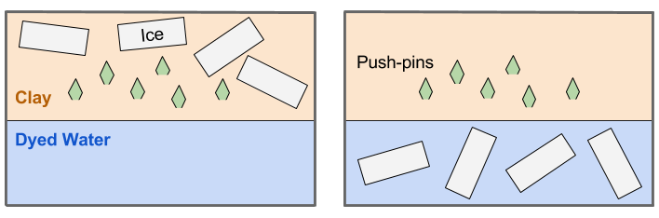

Engage | Melting Ice
Time: 15 minutes
Materials: Internet access and a projector
Knowledge Activation: Review the previous lessons, the Hydrologic Cycle and Seafloor Spreading, and ask, “How does the ocean change? And how do these changes impact ocean mechanics?” Specifically refer to the slowing global conveyor belt and spreading ocean floor.
Ask your class to share what they know about sea level rise and, “What causes sea level rise?” Show one of the following videos on ice melt:
- National Geographic 2017 short film (Recommended): http://bit.ly/2qjS9zl
- National Geographic 2015 Glacier National Park video: http://bit.ly/2qk1vLv
- National Geographic 2015 short film: http://bit.ly/2rUoE8i
- World Bank 2012 Andes video: http://bit.ly/2rZ5vRS
Ask, “How much do you think melting ice contributes to sea level rise?”

Explore | Eustatic Sea Level Rise
Time: 30 minutes
Materials: cold water, blue dye, conical flasks, corks, scissors, two-hole cork/stoppers, glass tubes, thermometers, rulers, lamps, outlets
Ask your students, “As Earth’s atmosphere continues to warm, what happens to the ocean?” After fielding answers, follow these steps to begin the thermal expansion activity:
Follow these steps with your students to create the thermal expansion models for a modified Windows to the Universe activity by Lisa Gardiner (see References):
- Break your class into pairs or teams of three and distribute the materials.
- Instruct students to fill the conical flasks with cold water and add blue dye.
- Insert the glass tube and thermometer into the two-hole cork.
- Insert the cork into the conical flask as shown in the graphic on the right.
- Instruct students to record the water’s level and temperature
- Have them place their thermal expansion model under a lamp, with the light shining on the water.
Knowledge Activation: While teams wait for their thermal expansion model to warm, discuss the gradual warming of Earth’s atmosphere, the natural and anthropogenic causes, potential solutions and adaptations. After the discussion, have the groups return to their thermal expansion models.
- Instruct students to record the water’s level and temperature.
- Ask each group to share their observations. Hold a brief discussion in regards to this experiment’s relationship to eustatic sea level rise.

Explain | Glacial Melt
Time: 30 minutes
Materials: glacial melt boxes (see Preparation), lamps, outlets
Knowledge Activation: Ask your students, “As Earth’s atmosphere continues to warm, what happens to the ice?” Then ask students, “Does the sea level change when ice melts?” Then ask, “Does the location of ice, either on land or in the ocean, make a difference?” After a brief discussion, follow these instructions to begin glacial melt activity:
- Distribute two glacial melt boxes (see Preparation) to each group.
- Instruct each team to label both boxes, one as the Iceberg Box and the second as the Glacier Box.
- Have one member of each team retrieve eight to twelve cubes of ice for their group. Instruct the groups to put half of the ice in the water of the Iceberg Box and the other half on the clay land in Glacier Box.
- Instruct the teams to record the water level in the Iceberg and Glacier boxes.
- Instruct them to place the boxes under the lamps.
While waiting for the ice to melt, ask, “How much of Earth’s water is contained in glaciers and ice caps?” After fielding answers, draw or display the following graphic introduced in the Hydrologic Cycle lesson.
After discuss the chart, return to the glacial melt boxes. Once all ice has melted follow these instructions to complete the activity:
- Instruct students to record the water levels in the Glacier and Iceberg boxes.
- Ask each group to share their observations. Hold a brief discussion in regards to this experiment’s relationship to eustatic sea level rise

Elaborate | Glacial Isostatic Adjustment
Time: 15 minutes
Materials: whiteboard or blackboard, dry-erase-markers or chalk, globe
Ask your students, “Have there always been glaciers on Earth’s surface?” Then ask, “What happens to continental crust when a glacier forms?” After fielding answers, review subsidence by drawing the graphic below.
Now ask, “What happens to the continental crust when glaciers melt?” Explain the process of uplift by using the following graphic.
Knowledge Activation: Ask, “If the continental crust under melting glaciers undergoes uplift, what happens to other areas of the continental shelf?” Explain glacial isostatic adjustment. To help students visualize this phenomenon, refer to the tectonic plate map from the previous lesson on Seafloor Spreading.

Evaluate | Changing Ocean Mechanics
Time: 15 minutes
Knowledge Activation: Ask, “How will the melting of ice impact thermohaline circulation?” To help students visualize this phenomenon, refer to the global conveyor belt map from the lesson on The Hydrologic Cycle. After discussing the relationship between water temperature and deep ocean currents, ask, “How does the global conveyor belt alter eustatic sea level rise?”
To help answer this question, you can show your class the following Kurzesagt video: http://bit.ly/2vnlhsz. This video gives an overview of thermohaline circulation and explains the possibility of thermohaline slowdown. Ask, “How could the possible slowdown of the global conveyor system impact regional sea level rise?”

Empower | Regional Sea Level Rise
Time: 15 minutes
Context Setting for Action Plan: Ask, “What are the consequences of sea level rise for coastal communities?” And then, “What other phenomena could worsen the effects of sea level rise?” Discuss storm surge, shoreline erosion, and regional subsidence with your students. The following two resources may help with engagement.
- National Geographic “Rising Seas” images: http://on.natgeo.com/2khiJGv
- National Geographic “Storm Surge” video: http://bit.ly/2ovUTNe
Have pairs or teams identify different communities subjected to regional sea level rise and have them compare the factors contributing to this phenomenon.

References
Alsup, Regan and Tim Watkins. “Why Melting Glaciers Matter to the Coasts.” National Park Service Climate Change Response Program: 2014. <http://bit.ly/2vDnYWa>
Folger, Tim and George Steinmetz. “Rising Seas.” National Geographic: 2013. <http://on.natgeo.com/2khiJGv>
Gardiner, Lisa. “Thermal Expansion and Sea Level Rise.” Windows to the Universe: 2007. <http://bit.ly/2gLq8QK>
“He’s Watching This Glacier Melt Before His Eyes.” Short Film Showcase. National Geographic: 2017. <http://bit.ly/2qjS9zl>
“Melting glaciers: The Slow Disaster in the Andes.” World Bank: 2012. <http://bit.ly/2rZ5vRS>
“Photo Evidence: Glacier National Park Is Melting Away.” National Geographic: 2015. <http://bit.ly/2qk1vLv>
“Sea Level Glossary.” Sea Level Change from Space. NASA. <https://sealevel.nasa.gov/glossary>
“See the Extreme Ice Changes Near the Antarctic Peninsula.” Short Film Showcase. National Geographic: 2015. <http://bit.ly/2rUoE8i>
“Storm Surge.” National Geographic: 2007. <http://bit.ly/2ovUTNe>
“The Gulf Stream Explained.” Kurzesagt: 2013. <http://bit.ly/2vnlhsz>

